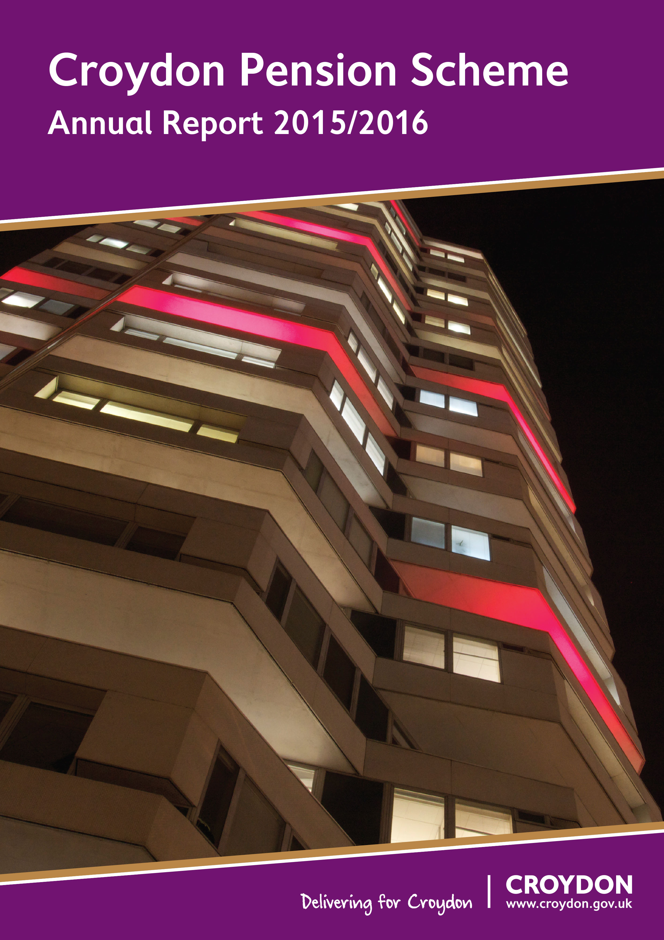

Foreword 3
1. Management and Advisers 5
2. Administrators to the Fund 7
2.1. Fund Managers: 7
2.2. Independent Advisers Retained by the Fund: 7
2.3. Frameworks 7
3. Publications 8
4. Membership 10
4.1. Organisations 10
4.1.1. Admitted 10
4.1.2. Scheduled 10
4.2. Resources for Members 11
4.2.1. Croydon Council Pension Web Site 11
4.2.2. National Local Government Pension Scheme Web Site 11
4.2.3. Additional Voluntary Contributions 11
4.2.4. Further Information 12
4.3. Members’ Self Service 13
5. Main Features of the Scheme 14
5.1. Eligibility for membership 14
5.2. Benefits on death in service 14
5.3. Benefits on retirement 14
5.4. Benefits on death after retirement 14
5.5. Extra benefits 15
5.6. Employee contributions 15
5.7. Age of retirement 16
5.8. Pensions Increases 16
5.9. Pension Fund Fraud / National Fraud Initiative 17
6. Changes to the Local Government Pension Scheme 18
6.1. The New LGPS 2014 18
6.1.1. LGPS 2014 – Communications 19
6.1.2. Payroll and HR Specifications 19
6.1.3. Consultations 19
7. Investment Policy 21
7.1. Monitoring the Investment Managers 23
7.2. Custody 23
8. Investment Report 24
8.1. Performance 24
8.2. Movement in the Market Value of the Fund 25
8.3. Distribution of Assets by Market Value 26
8.4. Statistics 2015/2016 27
8.5. Top 25 Global Holdings 28
9. Pension Fund Annual Accounts 2015/16 29
10. Pension Fund Auditors’ Report 52

Foreword


The Pension Committee, which since May it has been my privilege to chair, steers the main policies of the Pension Fund to provide for the good governance and stewardship of the Local Government Pension Scheme.

I must begin by thanking my predecessor, Councillor John Wentworth, for his hard work and diligence in chairing the Committee over the past two years. During his time as the Chair of the Committee the Pension Fund has grown significantly by 18.2 % from March 2014. Also the highest standards of governance have been set and the basis for a sustainable and affordable future for the Local Government Scheme established.

Thanks are also very much due to officers of the Council and the Fund's advisers Aon Hewitt for their care and advice in protecting the asset value of the Fund which is valued at £877.03 million as at March 31 2016.

The Pension Scheme serves a large community of its 25,000 members, and the other 80 Scheme employers, as well as the 3,400 teachers and NHS workers in their respective schemes that the council officer team also help. The Pension Committee is keen to conduct a positive dialogue with external Scheme employers so as to maintain timely payments into the Fund.

The period covered by the Annual Report saw major oil and commodity price weakness. There were strong pull backs in emerging markets values with the Fund having divested from direct emerging markets exposure in February 2015. The first significant correction in global equities in four years was weathered. The Greek crisis consumed a lot of market attention. Central bank Quantitative Easing inflated some asset prices and drove some government bond yields into negative yielding territory.

In the face of the storms that have rolled across the landscape your investments returned 1.9% over the year and that put this Fund in the top quarter of local government funds for the second year running.

Whatever the short-term vicissitudes of the markets the Pension Fund takes a long term view appropriate to its long-term liabilities.

Being very much aware of the distortion of asset values by Central Bank action and the Fund's overweight position in equities the Pension Committee conducted its periodic review of Statement of Investment Principles to plan for a transition of re-balancing the Fund's portfolio to include new investments in property, infrastructure and private equity.

The Pension Committee has also benefited from the scrutiny and strengthening of governance from the setting up a Local Pensions Board and you can find a report of their work here.

Councillor Andrew Pelling
Chair, Pension Committee
- Management & Advisers
Pension Committee:
The Council is the administrating authority for the Pension Fund and discharges its duties in respect of managing the Pension Fund through the Pensions Committee. The Committee is responsible for investments, administration and strategic management of the Council Pension Fund, including but not limited to:

- Setting the long term objectives and strategy for the Fund;
- Setting the investment strategy;
- Appointment of investment managers, advisers and custodian;
- Reviewing investment managers’ performance;
- Approving the actuarial valuation; and
- Approving pension fund publications including but not limited to the Statement of Investment Principles, the Funding Strategy Statement, the Governance Compliance and the Communication Policy Statement.

The Committee comprises eight voting Members of the Council and three non-voting members: two pensioner representatives and one employee representative. The members of Pensions Committee during the 2015/2016 Municipal year are listed below:

Councillors:
Chair: John Wentworth (Andrew Pelling from 23/05/2016)
Vice-Chair: Simon Hall
Members: Jan Buttinger
Maddie Henson
Yvette Hopley
Humayun Kabir
Dudley Mead
Andrew Pelling (Chairman from 23/05/2016)

Reserve Members: Carole Bonner, Robert Canning, Luke Clancy, Pat Clouder, Joy Prince, Donald Speakman

Non-voting members:
Pensioners’ Representatives: Gilli Driver
Peter Howard
Staff Representative: Isa Makumbi

The Committee is supported by officers and independent external advisers.

Administering Authority:
London Borough of Croydon (The London Borough of Croydon Pension Fund)
Finance and Assets Division, Resources Department
5A Bernard Weatherill House
8 Mint Walk
Croydon CR0 1EA

Richard Simpson
Executive Director of Resources

Investment Advisers:
Daniel Carpenter
AON Hewitt
The Aon Centre, The Leadenhall Building
122 Leadenhall Street
London EC3V 4AN

Actuary:
Richard Warden
Hymans Robertson LLP
20 Waterloo Street
Glasgow G2 6DB

Custodian of Assets:
Bank of New York Mellon
160 Queen Victoria Street
London EC4V 4LA

Auditors:
Grant Thornton UK LLP (External), Mazars (Internal)

Bankers:
Royal Bank of Scotland

Legal Advisers:
The Fund opts to procure legal advice on a case by case basis from the Croydon Council Legal Framework.

AVC Provider:
Prudential
Laurence Pountney Hill
London EC4R 0HH

National Association of Pension Funds (NAPF):
Membership number : 3547

- Administrators to the Fund

  - Fund Managers:










  - Independent Advisers Retained by the Fund:








  - Frameworks
The Croydon Fund is a Founder Member of the London CIV.
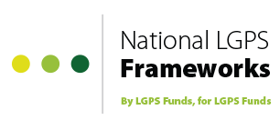
The Fund is also a Founder Member of the National LGPS Framework.

The Fund operates the Croydon Framework with 13
other administering authorities.

- Publications

The Pension Fund publishes a number of documents on the Council’s website www.croydonpensionscheme.org. Below is a brief outline of the key publications.

Funding Strategy Statement
The funding strategy statement is prepared in collaboration with the Fund’s Actuary and in consultation with the Fund’s employers and investment advisers. The statement includes:

- the strategy the Pension Fund employs to ensure its liabilities are met whilst maintaining a consistent and affordable employer contribution rate;
- details of how the Fund is seeking to achieve its investment objectives and the levels of associated risks; and
- the responsibilities for key parties including employers, employees and the Actuary.

Governance Compliance Statement
The administering authority of a Local Government Pension Scheme (LGPS) is required to publish a Governance Compliance Statement. The statement aims to make the administration and stewardship of the scheme more transparent and accountable to stakeholders and provides the following details:
- how the Council discharges its responsibilities, as the Fund’s Administering Authority, to maintain and manage the Fund in accordance with regulatory requirements;
- the structure of the decision making process;
- the frequency of Pension Committee meetings; and
- the voting rights of Committee members.

Statement of Investment Principles (SIP)
Administrating Authorities are required to prepare, maintain and publish a written statement of the principles governing their decisions about investments. The statement includes details of:
- the investment objective and style;
- the Fund’s investment managers and the terms of their mandates; and
- the Fund’s compliance with the Myners’ Investment Principles.

Communication Policy
Each administering authority is required to publish a statement setting out the Fund’s communication policy. The statement sets out the Council’s policy for:
- communicating with interested parties including members and other employers within the scheme; and
- the method and frequency of communications used such as newsletters, annual benefit statements, open days and the pensions website.

Training Log
Each administering authority is required to log each Pension Committee Member’s training.
- Membership
  - Organisations
    - Admitted:
Apetito
Impact Group Ltd
Interserve
Keyring
London Hire Services Ltd
Octavo
Olympic (South) Ltd
Quadron Services
Roman Catholic Archdiocese of Southwark
Ruskin Private Hire
Skanska Construction
Sodexo Ltd
Turning Point
Veolia Environmental Services (UK) Ltd
Veolia South West London Partnership
Vinci Facilities
Wallington Cars and Couriers
Westgate Cleaning Services

AXIS Europe plc
BRIT School
Capita Secure Information Solutions Ltd
Carillion Integrated Services
Churchill Services
Creative Environmental Networks
Croydon Care Solutions
Croydon Citizens’ Advice Bureau
Croydon Community Mediation
Croydon Voluntary Action
Eldon Housing Association
EM Highway Services Ltd
Fairfield (Croydon) Ltd
Fusion
Ground Control

    - Scheduled:
Addington High Academy  Aerodrome Primary Academy  Applegarth Academy  ARK Oval Primary Academy  Atwood Primary Academy  Broadmead Primary Academy  Castle Hill Academy  Chipstead Valley Primary School  Coulsdon College  Crescent Academy  Croydon College  David Livingstone Academy  Edenham High School  Fairchildes Academy Community Trust  Forest Academy  Gonville Academy  Good Shepherd Catholic Primary and Nursery School  Harris Primary Academy Purley Way  Harris Academy South Norwood  Harris Academy Upper Norwood  Harris City Academy Crystal Palace  Harris Invictus Academy  Harris Primary Academy Benson  Harris Primary Academy Kenley  Harris Primary Academy Haling Park  Heathfield Academy  John Ruskin College  New Valley Primary School | Norbury Manor Business and Enterprise College for Girls  Oasis Academy Arena  Oasis Academy Byron  Oasis Academy Coulsdon  Oasis Academy Ryelands  Oasis Academy Shirley Park Primary  Park Hill Junior School  Pegasus Academy  Paxton Academy  Riddlesdown Collegiate  Robert Fitzroy Academy  Rowdown Primary School  Shirley High School  St Cyprian's Greek Orthodox Primary Academy  St James the Great RC Primary and Nursery School  St Joseph's College  St Mark’s Church of England Primary School  St Mary’s Catholic Infant School  St Mary’s Catholic Junior School  St Thomas Becket Catholic Primary School  The Archbishop Lanfranc School  The Quest Academy  West Thornton Primary Academy  Winterbourne Boys’ Academy  Wolsey Junior Academy  Woodcote High School

  - Resources for Members

    - Croydon Council Pension Website
The Scheme’s Croydon website can be found at http://www.croydonpensionscheme.org/

    - National Local Government Pension Scheme Web Site
The web site address is www.lgps.org.uk and the address for the current scheme is www.lgps2014.org.

The national Local Government Pension Scheme web site enables all members, potential members and beneficiaries of the Scheme to access Scheme information 24 hours a day, 365 days a year.

The site has a comprehensive range of Scheme information; it is updated regularly to ensure members have access to the latest up to date information.

    - Additional Voluntary Contributions
The Council has appointed Prudential as the Scheme’s provider for additional voluntary contributions investment services.

Further information can be obtained by calling their helpline on 0845 607 0077 or by visiting the website www.pru.co.uk/rz/localgov/.

AVCs are an
opportunity for all
employees to pay
additional contributions into an
external scheme
which will enhance
income on retirement

Any members’ additional voluntary contributions (AVCs) are held in various separate investments administered by Prudential Assurance Company Limited. The benefits arising from these contributions are additional to, and do not form part of, the benefits due under the Local Government Pension Scheme. They are not included in the Pension Fund Accounts in accordance with section 4(2)(b) of the Local Government Pension Scheme (Management and Investment of Funds) Regulations 2009. Pension Fund Accounts and any details within the Annual Report therefore exclude amounts for AVCs.

    - Further Information

The Pensions Regulator
Napier House
Trafalgar Place
Brighton
East Sussex BN1 4DW
Telephone Number: 0845 600 0707 (Monday to Friday 09.00-17.00)
Website: www.thepensionsregulator.gov.uk
The role of the Pensions Regulator has been set out by Parliament, and is to:
• Protect the benefits of members of work-based pension schemes;
• Promote the good administration of work-based pension schemes;
• Reduce the risk of situations arising which may lead to claims for compensation from the Pensions Protection Fund.

The Pensions Advisory Service (TPAS)
11 Belgrave Road
London SW1V 1RB
Telephone Number: 0300 123 1047
Website: www.pensionsadvisoryservice.org.uk
TPAS is available to assist members of pension schemes with any difficulties that they are unable to resolve with their scheme administrators.

The Pensions Ombudsman
At the same address as TPAS
Telephone Number: 020 7630 2200
Website: www.pensions-ombudsman.org.uk
The Pensions Ombudsman can investigate and determine any complaint or disputes between scheme members and administrators, involving maladministration, or matters of fact or law.

The Pension Tracing Service
The Pension Service 9
Mail Handling Site A
Wolverhampton WV98 1LU
Telephone Number: 0345 6002 537
Website: www.gov.uk/find-lost-pension
The Pension Tracing Service can help ex-members of pension schemes, who may have lost touch with their previous employers, to trace their pension entitlements.

Queries relating to the Pension Fund investments can be made to:

The Pensions Section
5A, Bernard Weatherill House
8 Mint Walk
Croydon, CR0 1EA

Tel: 0208 760 5768 ext: 62892
E-mail: pensions@croydon.gov.uk

  - Members’ Self Service
Scheme members can view their pension details by logging on to our internet member self service. This service allows scheme members to check their personal details, including service history and financial information, as well as enabling members to carry out their own benefit calculations. Members can also check their record to make sure their nomination for their death grant is correct and, if applicable, that their record is up to date with their nominated co-habiting partner’s details.

Members can log in to the service at: https://croydon.pensiondetails.co.uk and request an activation code.
- Main Features of the Scheme

  - Eligibility for membership
Membership is generally available to employees of participating employers who have contracts of at least 3 months, are under age 75, and are not eligible for membership of other statutory pension schemes. Employees of designating bodies or admitted bodies can only join if covered by the relevant agreement.

  - Benefits on death in service
A lump sum is payable on death in service. This is normally equivalent to three years pay. The administering authority has absolute discretion over the distribution of this lump sum among the deceased’s relatives, dependants, personal representatives or nominees. Pensions may also be payable to the member’s widow, widower, civil partner, nominated cohabiting partner and dependent children.

  - Benefits on retirement
For membership from April 2014 onwards, pension benefits are based on career average revalued earnings and the accrual rate is 1/49th. Benefits for earlier membership consist of a pension calculated as 1/60th of final pay for each year of membership accrued from 1 April 2008 to 31 March 2014. The accrual rate is 1/80th of final pay for each year of membership accrued before 1 April 2008 plus a lump sum of three times the pension. Actual membership may be enhanced automatically in cases of ill health retirement. Employers may choose to increase pension. Members can normally exchange some pension to provide a bigger lump sum.

  - Benefits on death after retirement
A death grant is payable if less than 10 years pension has been paid and the pensioner is under age 75 at the date of death, in which case the balance of 10 years of pension is paid as a lump sum. Pensions are also generally payable to the pensioner’s widow, widower, civil partner, nominated cohabiting partner and dependent children.

  - Extra benefits
The scheme offers several ways for members to improve benefits:
- Payment of additional pension contributions (APCs) to buy extra pension; and
- A money purchase additional voluntary contribution (AVC) scheme which operates with the Prudential offering pension and life assurance options.

  - Employee contributions
The bands of contribution rates are as shown below for contributions taken in respect of pensionable pay received from 1st April 2015. The employee pays contributions at the appropriate band rate on all pensionable pay received in respect of that job (or at half that rate if the employee is in the 50/50 scheme).

Contribution Table 2015/16

Band | Actual pensionable pay for an employment | Contribution rate for that employment – main scheme | Contribution rate for that employment – 50/50 scheme
1 | Up to £13,600 | 5.5% | 2.75%
2 | £13,601 to £21,200 | 5.8% | 2.90%
3 | £21,201 to £34,400 | 6.5% | 3.25%
4 | £34,401 to £43,500 | 6.8% | 3.40%
5 | £43,501 to £60,700 | 8.5% | 4.25%
6 | £60,701 to £86,000 | 9.9% | 4.95%
7 | £86,001 to £101,200 | 10.5% | 5.25%
8 | £101,201 to £151,800 | 11.4% | 5.70%
9 | £151,800 or more | 12.5% | 6.25%
  - Age of retirement
Normal retirement age is now linked to State Pension Age, but:

- Pension benefits are payable at any age if awarded due to ill health;

- Members may retire with full accrued benefits from age 55 onwards if their retirement is on grounds of redundancy or business efficiency;

- Members who have left employment may request payment of benefits from age 55 onwards. Actuarial reductions may apply where benefits come into payment before the State Pension Age.

- Members who remain in employment may also ask to retire flexibly from age 55 onwards if they reduce their hours of work or grade. Employer consent is required and actuarial reductions may apply.

- Payment of benefits may be delayed beyond State Pension Age but only up to age 75.

  - Pensions Increases
Pensions payable to members who retire on health grounds and to dependants in receipt of a pension in respect of a deceased member are increased annually by law in line with increases in inflation. Pensions payable to other members who have reached the age of 55 also benefit from this annual inflation proofing. Where a member has an entitlement to a Guaranteed Minimum Pension (which relates to membership up to 5 April 1997), some or all of the statutory inflation proofing may be provided by the Department for Work and Pensions through the State Pension.

LGPS pensions are increased in line with the rise in the Consumer Price Index (CPI), in accordance with the Pensions Increase Act 1971. Although pensions are increased in April, they are based on the rise in the CPI over the 12 months to the previous September. The pensions increase calculation for April 2015 was based on the increase in CPI during the 12 months to September 2014 and was set at 1.2%.

  - Pension Fund Fraud / National Fraud Initiative
Following closure of the Audit Commission on 31 March 2015, The National Fraud Initiative (NFI), became the responsibility of the Cabinet Office. The NFI matches data from 1,300 public sector and 77 private sector organisations, including audit bodies in Scotland, Wales and Northern Ireland, government departments and other agencies. It flags up inconsistencies in the information that indicate a fraud, an error or an overpayment may have taken place, signaling the need for review and potential investigation.

For nearly two decades, the NFI has enabled the participants to detect fraud, overpayment and error totaling £1.17 billion. This includes £152 million detected in Scotland, Wales and Northern Ireland.

The use of data for NFI purposes continues to be controlled to ensure compliance with data protection and human rights legislation. A revised Code of data matching practice was published and laid before Parliament on 21 July 2008 and replaced the previous Code published by the Commission in 2006. The existing code of data matching practice will continue in effect until the Minister for the Cabinet Office issues a new code.

- Changes to the Local Government Pension Scheme

  - The New LGPS 2014
The new LGPS 2014 came into effect on 1 April 2014.

The main elements of the LGPS 2014 scheme are as follows:
- Career Average Revalued Earnings (CARE).

- 1/49th accrual rate with revaluation based on Consumer Prices Index (CPI).

- Retirement linked to State Pension Age (SPA).

- Contributions based on actual pay (including part time employees) with the average employee contribution remaining at 6.5%. No change to the expected overall net yield from employee contributions.

- Retention of banded employee contributions, but with an extension to the number of bands with little or no increase in the employee rate at the lower bands but more significant increases at higher pay bands, even after allowing for tax relief.

- ’50/50’ scheme option enabling members to pay half contributions for half the pension, with most other benefits remaining as they are currently.

- Benefits for service prior to 1st April 2014 are protected, including remaining ‘Rule of 85’ protection. Protected past service continues to be based on final salary and current retirement age.

- Outsourced scheme members will be able to stay in the scheme on first and subsequent transfers.

- Vesting period extended from 3 months back to two years.

All other terms remain as in the current scheme including death in service benefits, ill-health provision and the lump sum trade-off.

    - LGPS 2014 – Communications
The Local Government Pensions Committee (LGPC) have produced a wealth of guides, leaflets and publications for scheme administrators, employers, payroll sections and scheme members to assist with understanding and communicating the new scheme.

    - Payroll and HR Specifications
Following meetings with interested stakeholders, a payroll specification to assist employers and their software suppliers when developing payroll systems for April 2014 was published. In addition an HR specification has also been produced which contains information on the processes required to administer the scheme from April 2014.

Both specifications are available online from a new website http://www.lgpsregs.org/. This website will be the home of all employer and administering authority related information on the LGPS from April 2014. As well as the guidance noted above it contains the timeline regulations for the new scheme, access to statutory and GAD guidance, with links to other related legislation.

    - Consultations

1. Strengthening the incentive to save: a consultation on pensions tax relief
The consultation ran from 8 July 2015 to 30 September 2015 and a summary of responses was published in March 2016.

The government consulted on whether a case existed for reforming pensions tax relief to strengthen incentives to save and offer savers greater simplicity and transparency, or whether to keep the current system.

2. Consultation on a Public Sector Exit Payment cap
The consultation ran from 31 July 2015 to 27 August 2015.

The Government consulted on a policy proposal to limit the amount of redundancy and other exit payments (excluding pensions) that can be made to individuals leaving the public sector to £95,000. In terms of local government this could include pay in lieu of notice, redundancy and other severance payments as well as the employer cost of funding redundancy and efficiency retirements.

3. Consultation proposing to revoke and replace the Local Government Pension Scheme (Management and Investment of Funds) Regulations 2009
The consultation ran from 25 November 2015 to 19 February 2016.

The Government drafted a set of new regulations for the management and investment of LGPS funds and was seeking views on whether the proposed revisions to the investment regulations would give authorities the flexibility to determine a suitable investment strategy that appropriately takes account of risk and whether the proposals to introduce the power of intervention as a safeguard would enable the Secretary of State to intervene, when appropriate, to ensure that authorities take advantage of the benefits of scale offered by pooling and deliver investment strategies that adhere to regulation and guidance.

4. Consultation on Public sector exit payment recovery regulations
The consultation ran from 20 December 2015 to 25 January 2016.

The government consulted on draft regulations that would give effect to the powers enacted in the Small Business, Enterprise and Employment Act 2015, which allow for the recovery of exit payments when a high earner returns to the public sector shortly after exit.

5. Consultation on reforms to public sector exit payments
The consultation ran from 5 February 2016 to 3 May 2016.

The government consulted on options to reform public sector exit payment terms to ensure greater consistency, fairness and sustainability in the provision of public sector compensation.

- Investment Policy

As an administering pension authority, the Council discharges its duties in respect of maintaining the Pension Fund in the form of the Pension Committee. The strategic management of the assets is the responsibility of the Pension Committee that acts in consultation with Fund’s investment adviser; Aon Hewitt. Day-to-day management of the investments is carried out by investment managers, who have been appointed by the Pension Committee, acting under an agreed mandate and Council officers acting under delegated powers.

The Pension Committee has prepared a Statement of Investment Principles (SIP) in accordance with the Local Government Pension Scheme (Management and Investment of Funds) Regulations 2009 and after taking appropriate advice.

The SIP outlines the principles and policies governing investment decisions made by or on behalf of the Fund. It also reflects compliance with the ‘Myners Principles’.

As set out in the Regulations, the Pensions Committee will review the SIP from time to time, but at least every three years, and revise it as necessary. Also, in the event of a significant change in relation to any matter contained in the SIP, changes will be reflected within six months of the change occurring.

During the year a review of the asset allocation was carried out and as a result the Pensions Committee agreed a revised asset allocation at the September 2015 Pensions Committee and a revised SIP became effective from December 2015.

The SIP can be viewed at http://www.croydonpensionscheme.org/about-us/forms-and-publications.aspx.

Asset Allocation
The strategic asset allocation was reviewed during the year and a revised target asset allocation became effective in December 2015. The new asset allocation is as follows:

Asset Class | Investment
Equities | 42% +/- 5
Fixed Interest | 23% +/- 5
Alternatives | 34% +/- 5
Cash | 1%
Total | 100%

The Alternatives category is further broken down as follows:
Asset Class | Investment
Private Equity | 8%
Infrastructure | 10%
Property | 10%
Private Rental Sector Property (PRS) | 6%
Total | 34%

The Pensions Committee recognises that it will take a period of time in order to complete the transition to the revised asset allocation. This is due to the assets included within the Alternative category being illiquid and the time it takes to source investable opportunities. During the year progrees was made towards the transition of assets to the new investment stategy. Hedge funds were fully liquidated in October 2015 and the allocations to Private Equity, Infrastructure and Property all increased by 1.5% over the year. The Fund remained overweight in Equities, holding 56%. The transition to the new strategic asset allocation was and will continue to be monitored by the Pension Committee on a quarterly basis.

During the year two new managers were appointed; Access Capital Partners Limted which manages a Co-Investment vehicle investing in European Smallcaps and Temporis Capital LLP which manages a fund investing in Onshore Wind Farms. Further commitments were also made to our existing Infrastructure and Private Equity managers.

The distribution of the Fund’s assets among investment managers at 31st March 2016 is outlined below.

7.1 Monitoring the Investment Managers
Performance of the investment managers is reviewed formally at the quarterly Pension Committee meetings. To assist the Pensions Committee reports on Fund Managers performance were provided by the Council’s officers, State Street Performance Services and Aon Hewitt. Additionally, the Council’s officers and advisers meet the investment managers regularly to review their actions together with the reasons for their investment performance.
  - Custody
For the additional security of the invested assets, the Fund employs The Bank of New York Mellon as an independent custodian for its segregated global equity holdings. The Bank of New York Mellon also maintain records for all the Pension Fund investments, with the exception of internally managed cash.
- Investment Report

  - Performance
The Fund’s performance is compared with the Council’s own customised benchmarks and to the average return from 88 local authority pension funds, as measured by State Street Performance Services. During the 2015/2016 financial year the Fund’s return of 1.9% underperformed its customised benchmark of 2.1% by 0.2%. The Fund was placed in the upper quartile when compared to the other local authority pension funds outperforming the average return of 0.2% by 1.7%.

As at the 2013 Actuarial Valuation the Fund’s funding level was 66.3%, a marginal increase from the 66% funding level as calculated at the 2010 Actuarial Valuation. The next Actuarial Valuation is due effective 31 March 2016 and the results will be available in February 2017.
  - Movement in the Market Value of the Fund
The net assets of the Fund at 31 March 2016 were £877.03m compared with £501m at 31 March 2006. The chart below shows the growth of the Fund’s assets over the past ten years.

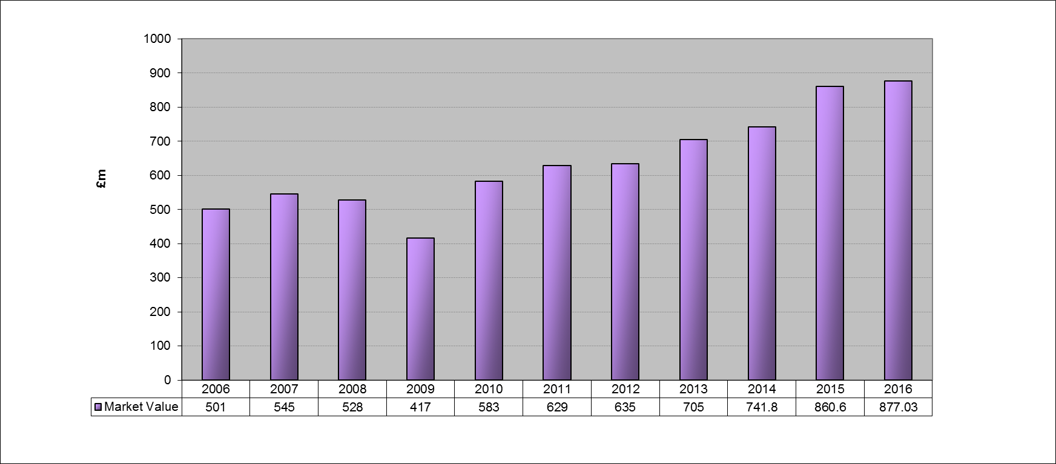

Note: percentages do not add up to 100% because of roundings
  - Distribution of Assets by Market Value

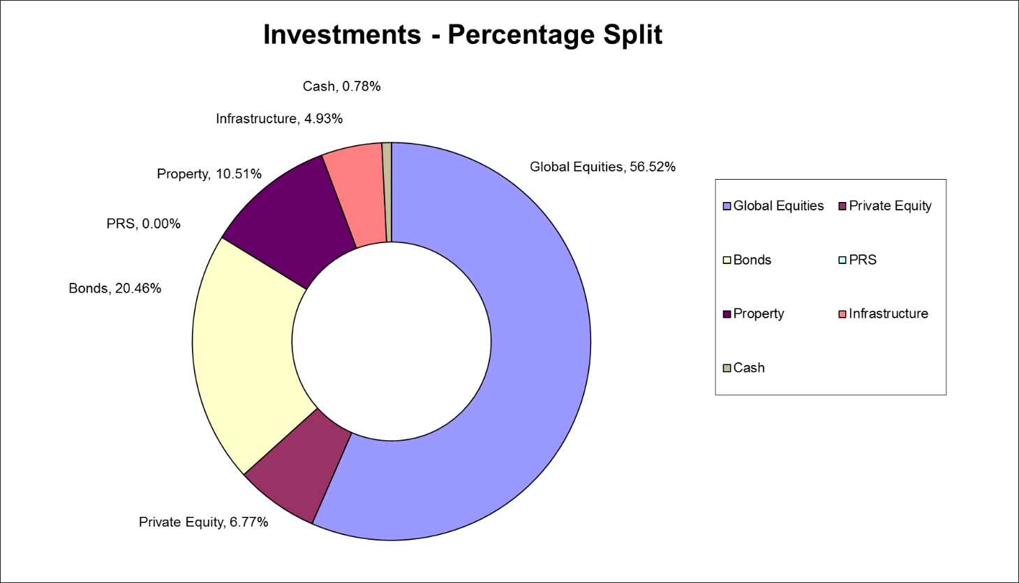

Note: percentages do not add up to 100% because of roundings

  - Statistics 2015/2016

Note: percentages do not add up to 100% because of roundings

  - Top 25 Global Holdings

- Pension Fund Annual Accounts 2015/16

A

- Pension Fund Auditors Report

INDEPENDENT AUDITOR’S REPORT TO THE MEMBERS OF LONDON BOROUGH OF CROYDON PENSION FUND

We have audited the pension fund financial statements of London Borough of Croydon (the "Authority") for the year ended 31 March 2016 under the Local Audit and Accountability Act 2014 (the "Act"). The pension fund financial statements comprise the Fund Account, the Net Assets Statement and the related notes. The financial reporting framework that has been applied in their preparation is applicable law and the CIPFA/LASAAC Code of Practice on Local Authority Accounting in the United Kingdom 2015/16.

This report is made solely to the members of the Authority, as a body, in accordance with Part 5 of the Act and as set out in paragraph 43 of the Statement of Responsibilities of Auditors and Audited Bodies published by Public Sector Audit Appointments Limited. Our audit work has been undertaken so that we might state to the members those matters we are required to state to them in an auditor's report and for no other purpose. To the fullest extent permitted by law, we do not accept or assume responsibility to anyone other than the Authority and the Authority's members as a body, for our audit work, for this report, or for the opinions we have formed.

Respective responsibilities of the Assistant Chief Executive (Corporate Resources and Section 151 Officer) and auditor

As explained more fully in the Statement of Responsibilities, the Assistant Chief Executive (Corporate Resources and Section 151 Officer) is responsible for the preparation of the Authority’s Statement of Accounts, which includes the pension fund financial statements, in accordance with proper practices as set out in the CIPFA/LASAAC Code of Practice on Local Authority Accounting in the United Kingdom 2015/16, which give a true and fair view. Our responsibility is to audit and express an opinion on the pension fund financial statements in accordance with applicable law and International Standards on Auditing (UK and Ireland). Those standards require us to comply with the Auditing Practices Board’s Ethical Standards for Auditors.

Scope of the audit of the pension fund financial statements

An audit involves obtaining evidence about the amounts and disclosures in the financial statements sufficient to give reasonable assurance that the financial statements are free from material misstatement, whether caused by fraud or error. This includes an assessment of whether the accounting policies are appropriate to the pension fund’s circumstances and have been consistently applied and adequately disclosed; the reasonableness of significant accounting estimates made by the Assistant Chief Executive (Corporate Resources and Section 151 Officer); and the overall presentation of the pension fund financial statements. In addition, we read all the financial and non-financial information in the Authority's Statement of Accounts Narrative Statement to identify material inconsistencies with the audited pension fund financial statements and to identify any information that is apparently materially incorrect based on, or materially inconsistent with, the knowledge acquired by us in the course of performing the audit. If we become aware of any apparent material misstatements or inconsistencies we consider the implications for our report.

Opinion on the pension fund financial statements

In our opinion the pension fund financial statements:
- present a true and fair view of the financial transactions of the pension fund during the year ended 31 March 2016 and of the amount and disposition at that date of the fund’s assets and liabilities, and
- have been properly prepared in accordance with the CIPFA/LASAAC Code of Practice on Local Authority Accounting in the United Kingdom 2015/16 and applicable law.

Opinion on other matters

In our opinion, the other information published together with the audited pension fund financial statements in the Authority's Statement of Accounts is consistent with the audited pension fund financial statements.

Elizabeth Jackson
for and on behalf of Grant Thornton UK LLP, Appointed Auditor

Grant Thornton House
Melton Street
Euston Square
London
NW1 2EP

29 September 2016

