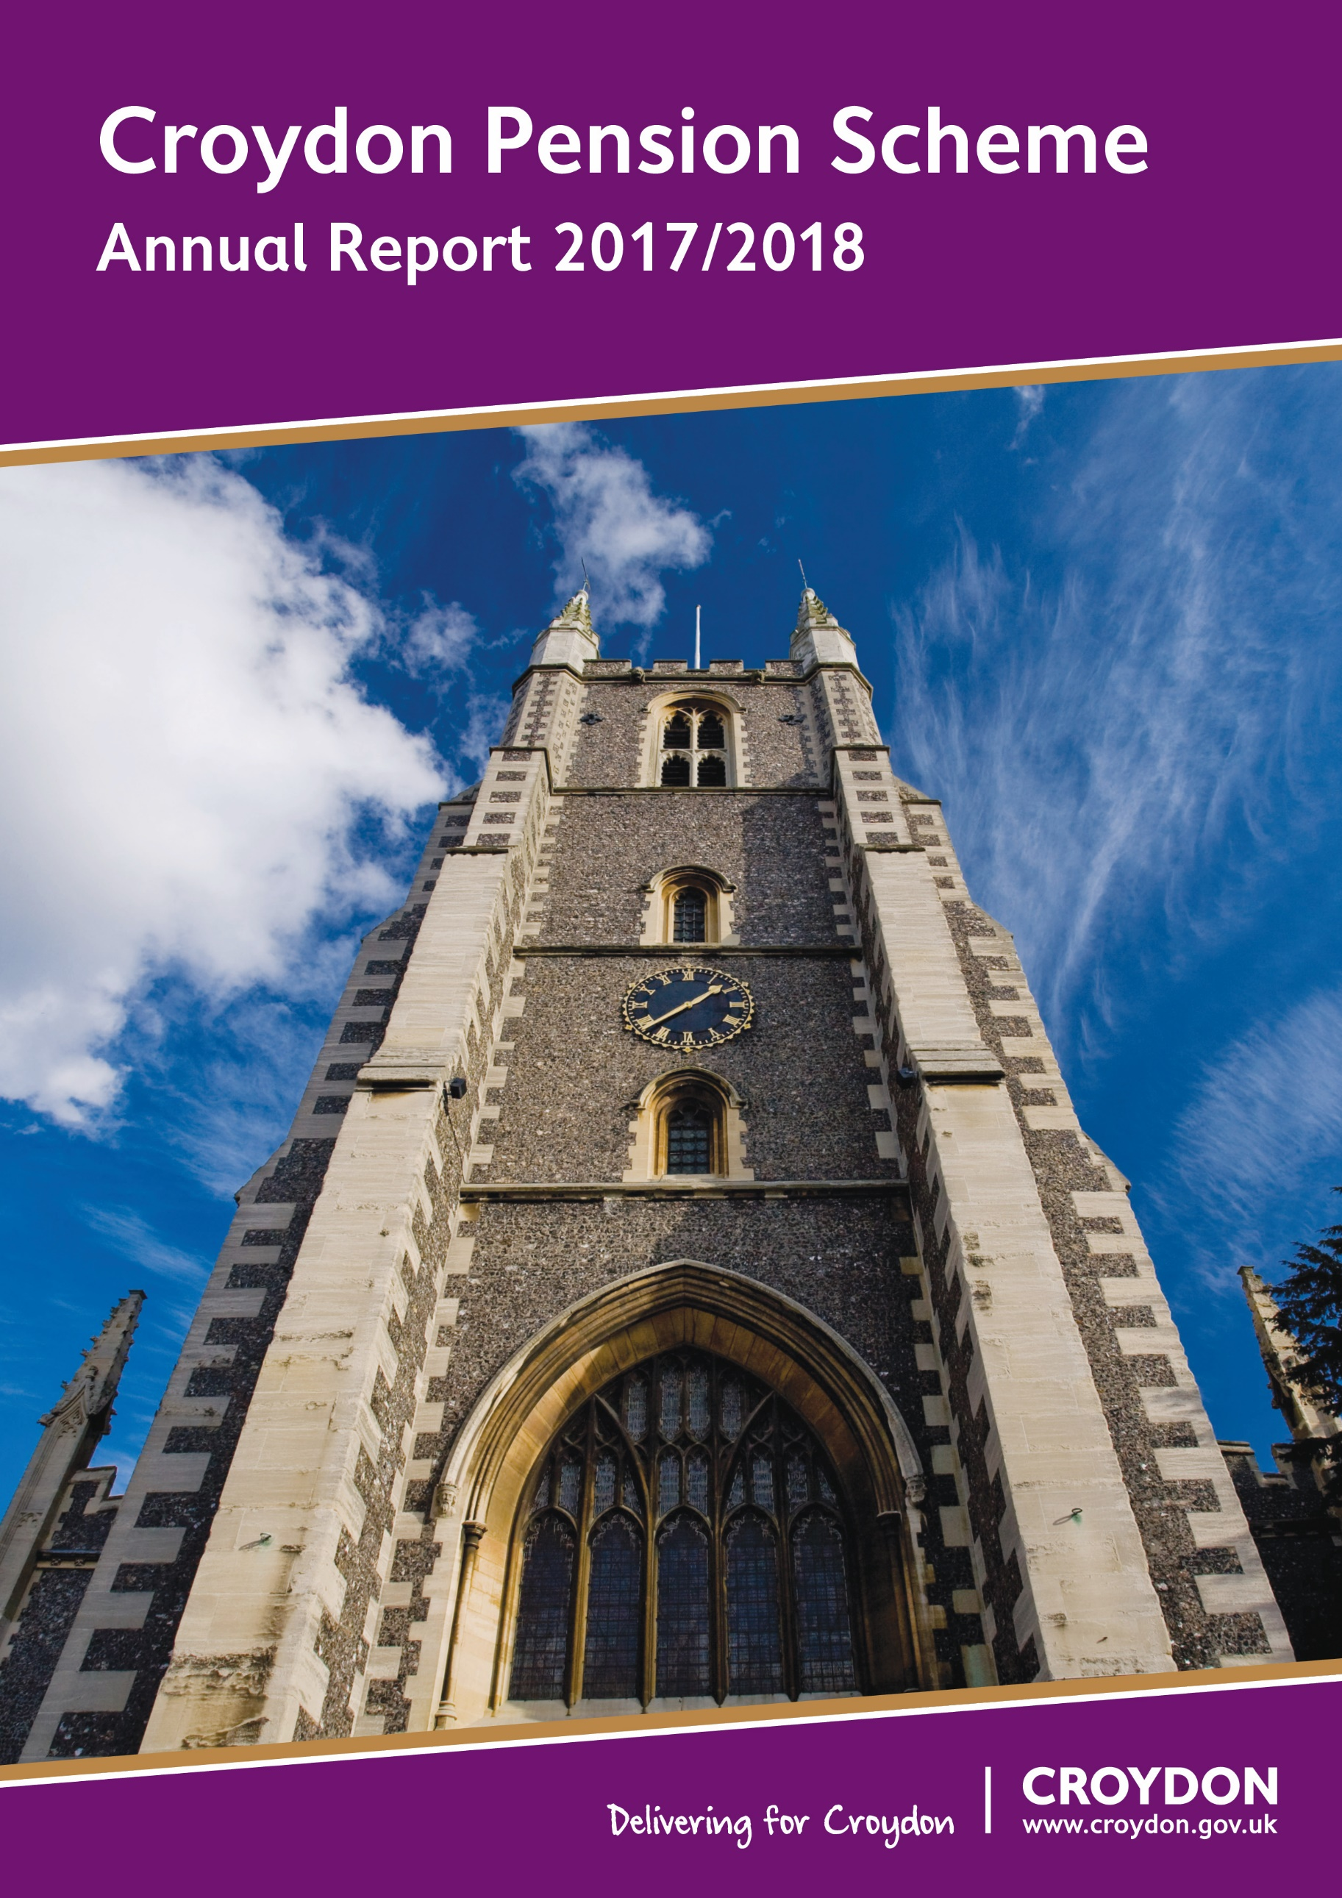

Foreword 3
1. Management & Advisers 5
2. Administrators to the Fund 7
2.1. Fund Managers: 7
2.2. Independent Advisers Retained by the Fund: 7
2.3. Frameworks 7
3. Publications 8
4. Membership 10
4.1. Organisations 10
4.1.1. Admitted: 10
4.1.2. Scheduled: 10
4.2. Resources for Members 11
4.2.1. Croydon Council Pension Website 11
4.2.2. National Local Government Pension Scheme Web Site 11
4.2.3. Additional Voluntary Contributions 11
4.2.4. Further Information 12
4.3. Members’ Self Service 13
5. Main Features of the Scheme 14
5.1. Eligibility for membership 14
5.2. Benefits on death in service 14
5.3. Benefits on retirement 14
5.4. Benefits on death after retirement 14
5.5. Extra benefits 15
5.6. Employee contributions 15
5.7. Age of retirement 15
5.8. Pensions Increases 16
5.9. Pension Fund Fraud / National Fraud Initiative 17
6. Changes to the Local Government Pension Scheme 18
6.1. The LGPS 2014 18
7. Investment Policy 19
7.1 Monitoring the Investment Managers 22
7.2 Custody 22
8. Investment Report 23
8.1. Performance 23
8.2. Movement in the Market Value of the Fund 24
8.3. Distribution of Assets by Market Value 25
8.4. Top 10 Global Holdings 26
9. Pension Fund Annual Accounts 2017/18 27
10. Pension Fund Auditors Report 52

Foreword

As the Chair of the Pensions Committee I am delighted to be able to present to you this Annual Report of the Croydon Council Pension Fund.

Croydon’s scheme has 107 employers, 27,000 members and assets of £1.14bn, up by 3.85% over the year.
Over the longer run of the past five years the Croydon Fund has secured a 9.2% growth per year with the Fund now being a Billion Pound fund and a full 273 % higher in value over the last nine years.
The Committee has been mindful of the length of the rally in global equity markets that has aided that strong Fund performance. Asset price inflation has been underpinned by central bank relaxed monetary stances expressed through Quantitative Easing, a policy only beginning to be unwound in the States and still much in place elsewhere.
Thus, the policy of the Committee is to reduce modestly the share of the Fund’s heightened exposure to equities, an extra exposure which has in the past led to the Fund’s overperformance during equity market rallies and underperformance by the Fund during equity market setbacks as was faced in the first quarter of 2018 (Q1 2018).
Robust economic growth in the US and improved Eurozone economy performance aided earnings results during 2017. US corporate tax changes boosted sentiment in a calm market with low volatility.
Come Q1 2018 that sentiment cooled and volatility spiked as worries over higher US interest rates prompted by that economic growth’s inflationary pressures and the possible normalisation of US monetary policy under a new Federal Reserve chair troubled investors.
Higher UK inflation, higher US rates across the yield curve, uncertainties over Brexit cooling UK business sentiment, tariff barriers to trade, political uncertainties in Italy, bank exposure to Italian banking debt, tensions on the Korean peninsula and a general decline in corporate credit quality all ushered in darker clouds on the market horizon as the financial year progressed.
In these circumstances the Committee felt further assured that capital protection and income enhancement in a low yield environment was best secured through its established policy of appropriate rebalancing of the Fund often into non-public equity assets with locked-in higher yields.
It was also felt that there was a need to include within the Fund’s equity holdings emerging market investments that might capture higher growth rates in those emerging markets economies. That investment was paused during heightened tensions in Korea and during a fast run up in emerging market equity values, but a decision was made in Q1 2018 to invest in an emerging markets fund under the umbrella of the London Pension Collective Investment Vehicle with that switch of equity investments to take place in the 2018-19 financial year.

Thus, the Pension Committee takes its responsibility to discharge its fiduciary role in the best interest of the Fund seriously.

Careful monitoring and reviews of developments, diversification across assets, regions and investment styles, and sound governance arrangements have all contributed to a steadily improving outlook for the Scheme. In addition to discharging its fiduciary responsibility to stakeholders the Committee is committed to ensuring that sound Environmental, Social and Governance practices are embedded in the investment strategy employed, specifically in respect of tobacco and fossil fuels.

The Committee also ensures that the Fund operates in accordance with the Local Government Pensions Scheme Regulations and adopts thorough going policies concerning the administration of the Fund.

Pooling of assets across the London Boroughs into the London Pension Collective Investment Vehicle (London CIV) that was set up by Chancellor Osborne is well underway with over half of the Croydon fund now within the scope of the London CIV.

This year has also seen significant developments in terms of governance, including consultations on the treatment of academy trusts, the election of pensioner representatives with a vote on pension matters, compliance with the EU directive on financial instruments and the Code of Transparency on managing investment costs. This year also saw changes to the state retirement age.

Two long standing members of the Committee have taken retirement and I would like to take this opportunity to thank Mr. Isa Makumbi and Councillor Dudley Mead for their combined forty years of service. They were stalwarts of the Committee who have given great service to the Fund’s members.

I would also like to thank my excellent Vice-Chair, Councillor Patricia Hay-Justice, for taking on the chairing of the Committee for Q1 2018 when my colleagues felt that I would benefit from an enforced break from the Committee.

I will conclude by also offering my thanks to the many professional officers and advisors listed within the pages of this report who have contributed to ensuring the continued success of this scheme.

Croydon is fortunate to have such professional and experienced officers in its Finance team.

Andrew Pelling
Chair, London Borough of Croydon Pension Committee
- Management & Advisers
Pension Committee:
The Council is the administrating authority for the Pension Fund and discharges its duties in respect of managing the Pension Fund through the Pensions Committee. The Committee is responsible for investments, administration and strategic management of the Council Pension Fund, including but not limited to:

- Setting the long term objectives and strategy for the Fund;
- Setting the investment strategy;
- Appointment of investment managers, advisers and custodian;
- Reviewing investment managers’ performance;
- Approving the actuarial valuation; and
- Approving pension fund publications including but not limited to the Statement of Investment Principles, the Funding Strategy Statement, the Governance Compliance and the Communication Policy Statement.

The Committee comprises of eight voting Members of the Council, one voting Pensioner Representative and two non-voting members being a Pensioner Representative and one Staff Representative.

The members of Pensions Committee during the 2017/2018 Municipal year are listed below:

Councillors:
Chair: Andrew Pelling to 07/12/17
Vice-Chair: Patricia Hay-Justice to 29/01/18, Chair from 29/01/18
Members: Simon Brew
Robert Canning from 07/12/17
Simon Hall
Maddie Henson
Yvette Hopley
Dudley Mead
Wayne Trakas-Lawlor from 07/12/17
John Wentworth to 07/12/17
Reserve Members: Jamie Audsley, Robert Canning to 07/12/17, Sherwan Chowdhury, Luke Clancy, Pat Clouder, Donald Speakman, Badsha Quadir

Other members:
Pensioners’ Representatives: Gilli Driver (Voting)
Peter Howard
Staff Representative: Isa Makumbi

The Committee is supported by officers and independent external advisers.

Administering Authority:
London Borough of Croydon (The London Borough of Croydon Pension Fund)
Finance and Assets Division, Resources Department, 5A Bernard Weatherill House
8 Mint Walk, Croydon CR0 1EA

Richard Simpson
Executive Director of Resources & S151 Officer

Investment Advisers:
AON Hewitt : Daniel Carpenter
The Aon Centre, The Leadenhall Building
122 Leadenhall Street
London EC3V 4AN

Actuary:
Hymans Robertson LLP : Richard Warden
20 Waterloo Street
Glasgow G2 6DB

Local Pensions Board:
c/o London Borough of Croydon (The London Borough of Croydon Pension Fund)
Finance Investment and Risk, Resources Department
5A Bernard Weatherill House
8 Mint Walk
Croydon CR0 1EA
Chair: Michael Ellsmore

Custodian of Assets:
Bank of New York Mellon
160 Queen Victoria Street
London EC4V 4LA

Auditors:
Grant Thornton UK LLP (External), Mazars (Internal)

Bankers:
Royal Bank of Scotland

Legal Advisers:
The Fund opts to procure legal advice on a case by case basis from the Croydon Council Legal Framework.

AVC Provider:
Prudential
Laurence Pountney Hill, London EC4R 0HH

Pensions and Lifetime Savings Association (PLSA):
Membership number : 3547
- Administrators to the Fund

  - Fund Managers:















  - Independent Advisers Retained by the Fund:







  - Frameworks

The Croydon Fund is a Founder Member of the London CIV.

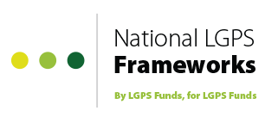
The Fund is also a Founder Member of the National LGPS Framework.

- Publications

The Pension Fund publishes a number of documents on the Council’s website www.croydonpensionscheme.org Below is a brief outline of the key publications.

Funding Strategy Statement
The funding strategy statement is prepared in collaboration with the Fund’s Actuary and in consultation with the Fund’s employers and investment advisers. The statement includes:

- the strategy the Pension Fund employs to ensure its liabilities are met whilst maintaining a consistent and affordable employer contribution rate;
- details of how the Fund is seeking to achieve its investment objectives and the levels of associated risks; and
- the responsibilities for key parties including employers, employees and the Actuary.

Governance Compliance Statement
The administering authority of a Local Government Pension Scheme (LGPS) is required to publish a Governance Compliance Statement. The statement aims to make the administration and stewardship of the scheme more transparent and accountable to stakeholders and provides the following details:
- how the Council discharges its responsibilities, as the Fund’s Administering Authority, to maintain and manage the Fund in accordance with regulatory requirements;
- the structure of the decision making process;
- the frequency of Pension Committee meetings; and
- the voting rights of Committee members.

Investment Strategy Statement (ISS)
From 1 April 2017, Administrating Authorities are required to prepare, maintain and publish a written Investment Strategy Statement. The ISS includes details of the Fund’s:

- investment objectives;
- asset allocation;
- risk management;
- approach to pooling of assets;
- environmental, social and governance (ESG) policy; and
- Voting policy.

Communication Policy
Each administering authority is required to publish a statement setting out the Fund’s communication policy. The statement sets out the Council’s policy for:
- communicating with interested parties including members and other employers within the scheme; and
- the method and frequency of communications used such as newsletters, annual benefit statements, open days and the pensions website.

Training Log
Each administering authority is required to log each Pension Committee Member’s training.
- Membership
  - Organisations
    - Admitted:
Keyring Living Support Networks
London Hire Services Limited
Octavo Partnership Limited
Olive Dining
Olympic (South) Limited
Quadron Services Limited
Roman Catholic Archdiocese of Southwark
Ruskin Private Hire
Skanska Construction Limited
Sodexo Limited
Veolia Environmental Services (UK) Limited
Veolia South West London Partnership – Kingston
Veolia South West London Partnership – Sutton & Merton
Vinci Facilities Limited
Wallington Cars and Couriers Limited
Westgate Cleaning Services Limited

Arthur Mckay
AXIS Europe plc
BRIT School
Capita Secure Information Solutions Limited
Carillion Integrated Services Limited
Churchill Services Limited
Croydon Care Solutions Limited
Croydon Citizens’ Advice Bureau
Croydon Community Mediation
Croydon Voluntary Action
Fusion Lifestyle
Ground Control
Kier Highways Limited
Idverde South London Waste Partnership
Impact Group Limited
Interserve plc

    - Scheduled:
Aerodrome Primary Academy  Applegarth Academy  ARK Oval Primary Academy  Atwood Primary Academy  Broadmead Primary Academy  Castle Hill Academy  Chestnut Park Primary School  Chipstead Valley Primary School  Christchurch Primary  Coulsdon College  Crescent Primary Academy  Croydon College  Davidson Primary Academy  David Livingstone Academy  Edenham High School  Fairchildes Primary School  Forest Academy  Gonville Academy  Good Shepherd Catholic Primary  Harris Primary Academy Purley Way  Harris Academy South Norwood  Harris City Academy Crystal Palace  Harris Invictus Academy  Harris Primary Academy Benson  Harris Primary Academy Kenley  Harris Primary Academy Haling Park  Harris Academy Purley  Heathfield Academy  John Ruskin College  Kingsley Primary School  Krishna Avanti Primary School  Meridian High School  New Valley Primary School | Norbury Manor Business and Enterprise College  Oasis Academy Arena  Oasis Academy Byron  Oasis Academy Coulsdon  Oasis Academy Ryelands  Oasis Academy Shirley Park Primary  Park Hill Junior School  Pegasus Academy  Paxton Academy  Robert Fitzroy Academy  Rowdown Primary School  Shirley High School  South Norwood Academy  St Aidan’s Primary School  St Chad’s Primary School  St Cyprian's Greek Orthodox Primary Academy  St James the Great RC P & N School  St Joseph's College  St Mark’s Church of England Primary School  St Mary’s Catholic Infant School  St Mary’s Catholic Junior School  St Thomas Becket Catholic Primary School  The Archbishop Lanfranc School  The Brit School  The Collegiate Trust  The Quest Academy  West Thornton Primary Academy  Winterbourne Boys’ Academy  Wolsey Junior Academy  Woodcote High School  Woodside Academy

  - Resources for Members

    - Croydon Council Pension Website
The Scheme’s website can be found at http://www.croydonpensionscheme.org/

    - National Local Government Pension Scheme Web Site
The web site address is www.lgpsmember.org/

The national Local Government Pension Scheme web site enables all members, potential members and beneficiaries of the Scheme to access Scheme information 24 hours a day, 365 days a year.

The site has a comprehensive range of Scheme information; it is updated regularly to ensure members have access to the latest up to date information.

    - Additional Voluntary Contributions
The Council has appointed Prudential as the Scheme’s provider for additional voluntary contributions investment services.

Further information can be obtained by calling their helpline on 0845 434 6629 or by visiting the website www.pru.co.uk/rz/localgov/.

AVCs are an
opportunity for all
employees to pay
additional contributions into an
external scheme
which will enhance
income on retirement

Any members’ additional voluntary contributions (AVCs) are held in various separate investments administered by Prudential Assurance Company Limited. The benefits arising from these contributions are additional to, and do not form part of, the benefits due under the Local Government Pension Scheme. They are not included in the Pension Fund Accounts in accordance with section 4(2)(b) of the Local Government Pension Scheme (Management and Investment of Funds) Regulations 2009. Pension Fund Accounts and any details within the Annual Report therefore exclude amounts for AVCs.

    - Further Information

The Pensions Regulator
Napier House
Trafalgar Place
Brighton
East Sussex BN1 4DW
Telephone Number: 0845 600 0707 (Monday to Friday 09.00-17.00)
Website: www.thepensionsregulator.gov.uk
The role of the Pensions Regulator has been set out by Parliament, and is to:
• Protect the benefits of members of work-based pension schemes;
• Promote the good administration of work-based pension schemes;
• Reduce the risk of situations arising which may lead to claims for compensation from the Pensions Protection Fund.

The Pensions Advisory Service (TPAS)
11 Belgrave Road
London SW1V 1RB
Telephone Number: 0300 123 1047
Website: www.pensionsadvisoryservice.org.uk
TPAS is available to assist members of pension schemes with any difficulties that they are unable to resolve with their scheme administrators.

The Pensions Ombudsman
At the same address as TPAS
Telephone Number: 020 7630 2200
Website: www.pensions-ombudsman.org.uk
The Pensions Ombudsman can investigate and determine any complaint or disputes between scheme members and administrators, involving maladministration, or matters of fact or law.

The Pension Tracing Service
The Pension Service 9
Mail Handling Site A
Wolverhampton WV98 1LU
Telephone Number: 0345 6002 537
Website: www.gov.uk/find-lost-pension
The Pension Tracing Service can help ex-members of pension schemes, who may have lost touch with their previous employers, to trace their pension entitlements.

Queries relating to the Pension Fund investments can be made to:

The Pensions Section
5A, Bernard Weatherill House
8 Mint Walk
Croydon, CR0 1EA

Tel: 0208 760 5768 ext: 62892
E-mail: pensions@croydon.gov.uk

  - Members’ Self Service
Scheme members can view their pension details by logging on to our internet member self service. This service allows scheme members to check their personal details, including service history and financial information, as well as enabling members to carry out their own benefit calculations. Members can also check their record to make sure their nomination for their death grant is correct and, if applicable, that their record is up to date with their nominated co-habiting partner’s details.

Members can log in to the service at: https://croydon.pensiondetails.co.uk and request an activation code.
- Main Features of the Scheme

  - Eligibility for membership
Membership is generally available to employees of participating employers who have contracts of at least 3 months, are under age 75, and are not eligible for membership of other statutory pension schemes. Employees of designating bodies or admitted bodies can only join if covered by the relevant agreement.

  - Benefits on death in service
A lump sum is payable on death in service. This is normally equivalent to three years pay. The administering authority has absolute discretion over the distribution of this lump sum among the deceased’s relatives, dependants, personal representatives or nominees. Pensions may also be payable to the member’s widow, widower, civil partner, nominated cohabiting partner and dependent children.

  - Benefits on retirement
For membership from April 2014 onwards, pension benefits are based on career average revalued earnings and the accrual rate is 1/49th. Benefits for earlier membership consist of a pension calculated as 1/60th of final pay for each year of membership accrued from 1 April 2008 to 31 March 2014. The accrual rate is 1/80th of final pay for each year of membership accrued before 1 April 2008 plus a lump sum of three times the pension. Actual membership may be enhanced automatically in cases of ill health retirement. Employers may choose to increase pension. Members can normally exchange some pension to provide a bigger lump sum.

  - Benefits on death after retirement
A death grant is payable if less than 10 years pension has been paid and the pensioner is under age 75 at the date of death, in which case the balance of 10 years of pension is paid as a lump sum. Pensions are also generally payable to the pensioner’s widow, widower, civil partner, nominated cohabiting partner and dependent children.

  - Extra benefits
The scheme offers several ways for members to improve benefits:
- Payment of additional pension contributions (APCs) to buy extra pension; and
- A money purchase additional voluntary contribution (AVC) scheme which operates with the Prudential offering pension and life assurance options.

  - Employee contributions
The bands of contribution rates are as shown below for contributions taken in respect of pensionable pay received from 1 April 2018. The employee pays contributions at the appropriate band rate on all pensionable pay received in respect of that job (or at half that rate if the employee is in the 50/50 scheme).

Contribution Table 2018/19

Band | Actual pensionable pay for an employment | Contribution rate for that employment – main scheme | Contribution rate for that employment – 50/50 scheme
1 | Up to £14,100 | 5.5% | 2.75%
2 | £14,101 to £22,000 | 5.8% | 2.90%
3 | £22,001 to £35,700 | 6.5% | 3.25%
4 | £35,701 to £45,200 | 6.8% | 3.40%
5 | £45,201 to £63,100 | 8.5% | 4.25%
6 | £63,101 to £89,400 | 9.9% | 4.95%
7 | £89,401 to £105,200 | 10.5% | 5.25%
8 | £105,201 to £157,800 | 11.4% | 5.70%
9 | £157,801 or more | 12.5% | 6.25%
  - Age of retirement
Normal retirement age is now linked to State Pension Age, but:

- Pension benefits are payable at any age if awarded due to ill health;

- Members may retire with fully accrued benefits from age 55 onwards if their retirement is on grounds of redundancy or business efficiency;

- Members who have left employment after the 1 April 2014 may request payment of benefits from age 55 onwards. Actuarial reductions may apply where benefits come into payment before the State Pension Age.

- Members who remain in employment may also ask to retire flexibly from age 55 onwards if they reduce their hours of work or grade. Employer consent is required and actuarial reductions may apply.

- Payment of benefits may be delayed beyond State Pension Age but only up to age 75.

  - Pensions Increases
Pensions payable to members who retire on health grounds and to dependants in receipt of a pension in respect of a deceased member are increased annually by law in line with increases in inflation. Pensions payable to other members who have reached the age of 55 also benefit from this annual inflation proofing. Where a member has an entitlement to a Guaranteed Minimum Pension (which relates to membership up to 5 April 1997), some or all of the statutory inflation proofing may be provided by the Department for Work and Pensions through the State Pension.

LGPS pensions are increased in line with the rise in the Consumer Price Index (CPI), in accordance with the Pensions Increase Act 1971. Although pensions are increased in April, they are based on the rise in the CPI over the 12 months to the previous September. The pensions increase calculation for April 2017 was based on the increase in CPI during the 12 months to September 2016 and was set at 1.0%.

  - Pension Fund Fraud / National Fraud Initiative
This organisation is required to protect the public funds it administers. It may share information provided to it with other bodies responsible for; auditing, or administering public funds, or where undertaking a public function, in order to prevent and detect fraud.

The Cabinet Office is responsible for carrying out data matching exercises.

Data matching involves comparing computer records held by one body against other computer records held by the same or another body to see how far they match. This is usually personal information. Computerised data matching allows potentially fraudulent claims and payments to be identified. Where a match is found it may indicate that there is an inconsistency which requires further investigation. No assumption can be made as to whether there is fraud, error or other explanation until an investigation is carried out.

We participate in the Cabinet Office’s National Fraud Initiative: a data matching exercise to assist in the prevention and detection of fraud. We are required to provide particular sets of data to the Minister for the Cabinet Office for matching for each exercise, as detailed here.

The use of data by the Cabinet Office in a data matching exercise is carried out with statutory authority under Part 6 of the Local Audit and Accountability Act 2014. It does not require the consent of the individuals concerned under the Data Protection Act 1998.

Data matching by the Cabinet Office is subject to a Code of Practice.

View further information on the Cabinet Office’s legal powers and the reasons why it matches particular information. For further information on data matching at this authority contact caft@croydon.gov.uk .

- Changes to the Local Government Pension Scheme

  - The LGPS 2014
The LGPS 2014 came into effect on 1 April 2014.

The main elements of the LGPS 2014 scheme are as follows:
- Career Average Revalued Earnings (CARE).

- 1/49th accrual rate with revaluation based on Consumer Prices Index (CPI).

- Retirement linked to State Pension Age (SPA).

- Contributions based on actual pay (including part time employees) with the average employee contribution remaining at 6.5%. No change to the expected overall net yield from employee contributions.

- Retention of banded employee contributions, but with an extension to the number of bands with little or no increase in the employee rate at the lower bands but more significant increases at higher pay bands, even after allowing for tax relief.

- ’50/50’ scheme option enabling members to pay half contributions for half the pension, with most other benefits remaining as they are currently.

- Benefits for service prior to 1st April 2014 are protected, including remaining ‘Rule of 85’ protection. Protected past service continues to be based on final salary and current retirement age.

- Outsourced scheme members will be able to stay in the scheme on first and subsequent transfers.

- Vesting period extended from 3 months back to two years.

All other terms remain as in the current scheme including death in service benefits, ill-health provision and the lump sum trade-off.

- Investment Policy

As an administering pension authority, the Council discharges its duties in respect of maintaining the Pension Fund in the form of the Pension Committee. The strategic management of the assets is the responsibility of the Pension Committee that acts in consultation with the Fund’s investment adviser; Aon Hewitt. Day-to-day management of the investments is carried out by investment managers, who have been appointed by the Pension Committee, acting under an agreed mandate and Council officers acting under delegated powers.

The Pension Committee has prepared an Investment Strategy Statement (ISS) in accordance with the Local Government Pension Scheme (Management and Investment of Funds) Regulations 2016 and after taking appropriate advice.

The ISS outlines the principles and policies governing investment decisions made by or on behalf of the Fund.

As set out in the Regulations, the Committee will review the ISS from time to time and at least every three years. In the event of any material change to any matter contained within the ISS, changes will be reflected within six months of the change occurring.

The ISS can be viewed at: http://www.croydonpensionscheme.org/croydon-pension-fund/about-us/forms-and-publications/

Asset Allocation
The current strategic asset allocation came into force in December 2015. The target asset allocation is as follows:
Asset Class | Investment
Equities | 42% +/- 5
Fixed Interest | 23% +/- 5
Alternatives | 34% +/- 5
Cash | 1%
Total | 100%

The Alternatives category is further broken down as follows:
Asset Class | Investment
Private Equity | 8%
Infrastructure | 10%
Property | 10%
Private Rental Sector Property (PRS) | 6%
Total | 34%

The Pensions Committee recognises that it will take a period of time in order to complete the transition to the revised asset allocation. This is due to the assets included within the Alternative category being illiquid and the time it takes to source investable opportunities. During the year further progress was made towards the transition of assets to the new asset allocation strategy. The Fund reduced its overweight holding in global equities from 52.1% to 50.8%. The Fund’s allocation to Private Equity remained in line with the target allocation at 8.4%. The Fund appointed two new managers to manage our Infrastructure allocation. Access Infrastructure and I-Squared were appointed and with increases in allocations to existing managers, the Infrastructure allocation increased from 7.5% to 10%. It is now at our target allocation. Further drawdowns were made by our PRS manager, M&G to increase the allocation to PRS from to 1.0% to 2.2%. The Fund is on track to meet the asset allocation by the middle of 2018/19 as planned. The transition to the new asset allocation was and will continue to be monitored by the Pension Committee on a quarterly basis.

The Fund also transferred its Global Equity mandate with Legal & General from a segregated arrangement to a pooled one. This was to take advantage of the fee discounts negotiated by the London CIV. The Markham Rae fund was unable to make an investment, so closed at the year end.

The distribution of the Fund’s assets among investment managers at 31st March 2018 is outlined below.

7.1 Monitoring the Investment Managers
Performance of the investment managers is reviewed formally at the quarterly Pension Committee meetings. To assist the Pensions Committee reports on Fund Managers performance were provided by the Council’s officers and Aon Hewitt. Additionally, the Council’s officers and advisers meet the investment managers regularly to review their actions together with the reasons for their investment performance.
  - Custody
For the additional security of the invested assets, the Fund employs The Bank of New York Mellon as an independent custodian for its segregated global equity holdings. The Bank of New York Mellon also maintain records for all the Pension Fund investments, with the exception of internally managed cash.
- Investment Report

  - Performance
The Fund’s performance is compared with the Council’s own customised benchmarks. During the 2017/2018 financial year the Fund returned 3.85%, underperforming its customised benchmark of 6.44% by 2.59%. The underperformance was due to the negative performance of Global Equities in the last quarter of the year. Global Equities rebounded by 8% in the following quarter. The Pensions Committee did manage to lock in some of the gains from Global Equities in the first three quarters of the year.
The Pension Fund’s investments continue to perform strongly in both the medium term (shown below) and the long term.

The annualised investment returns for 1, 3 and 5 years are given in the table below:

At the 2016 Actuarial Valuation the Fund had a funding level of 73%. The Fund is making good progress towards achieving its objective of a 100% funding level. The next Actuarial Valuation is due effective 31 March 2019 and the results will be available in February 2020.

  - Movement in the Market Value of the Fund
The net assets of the Fund at 31 March 2018 were £1,139.4m compared with £528m at 31 March 2008. The chart below shows the growth of the Fund’s assets over the past ten years.

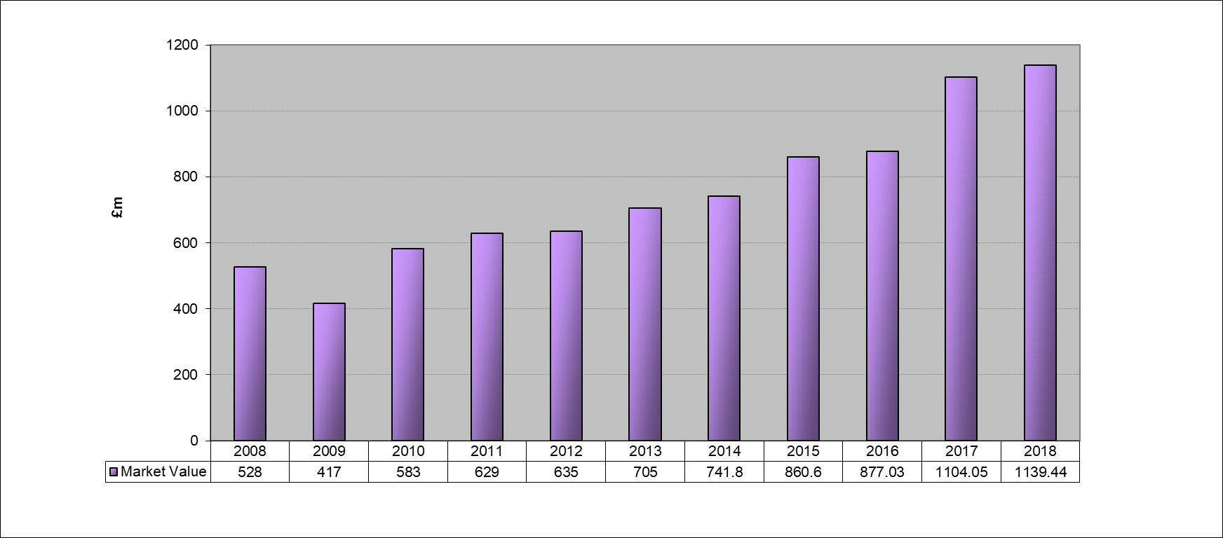

  - Distribution of Assets by Market Value
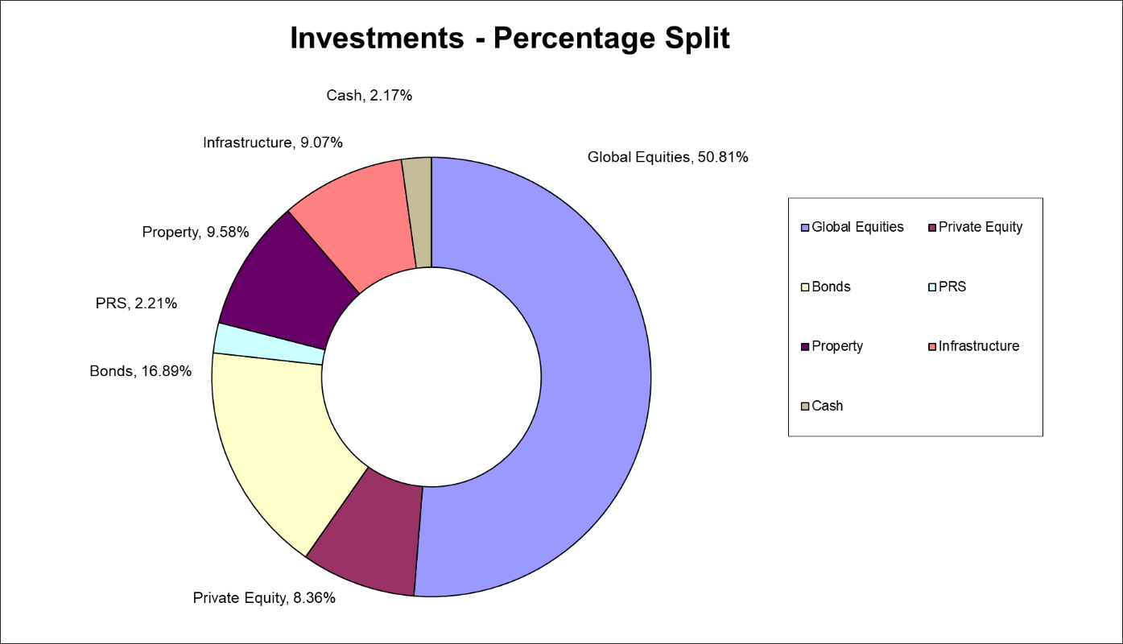

Note: percentages do not add up to 100% because of roundings

  - Top 10 Global Holdings

- Pension Fund Annual Accounts 2017/18
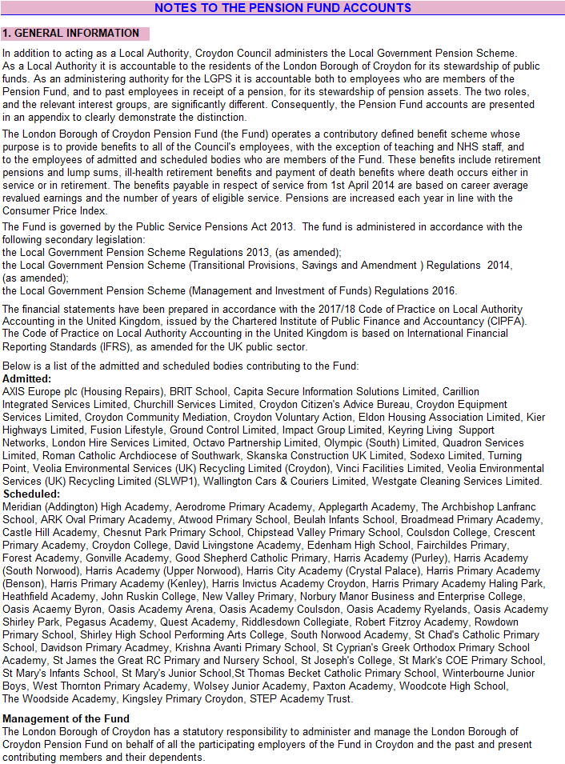
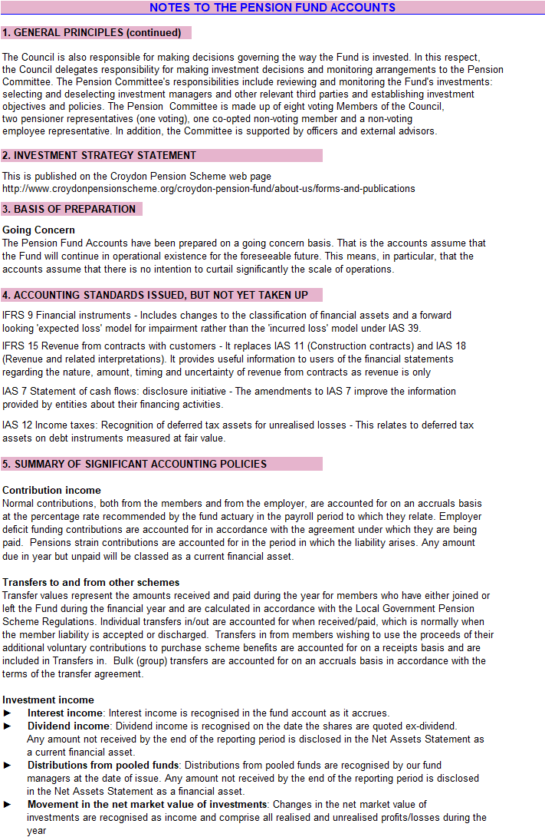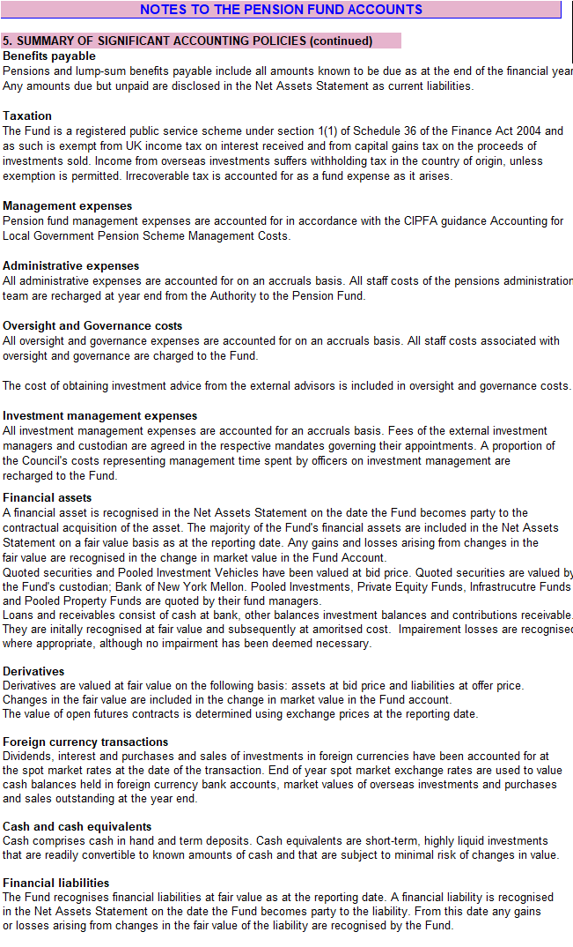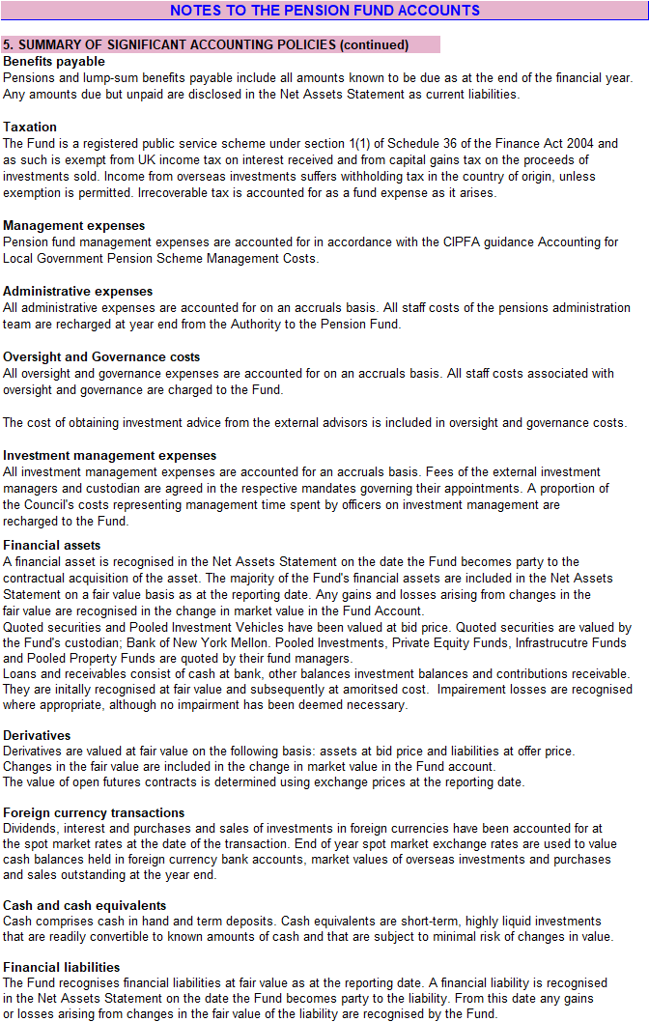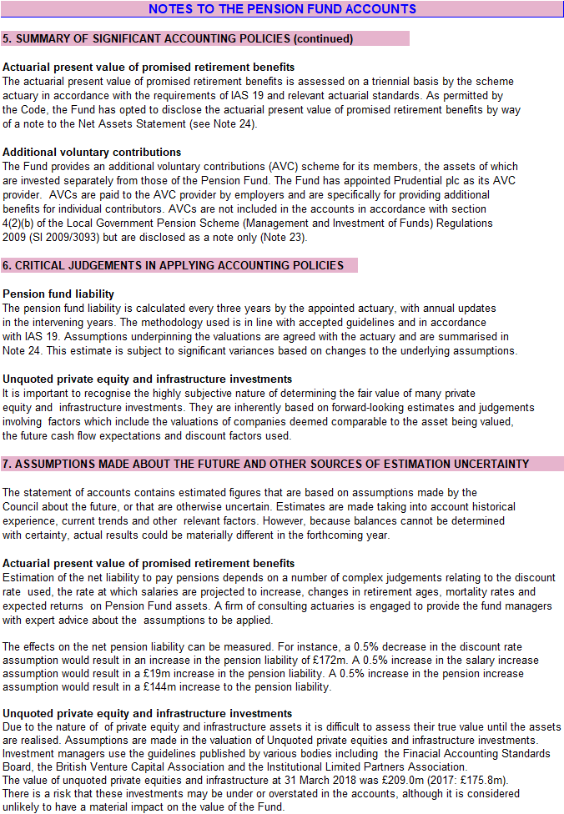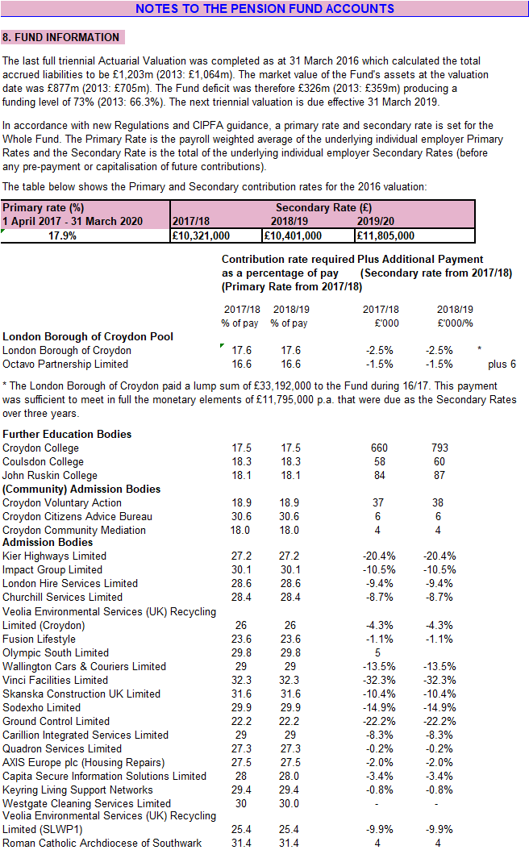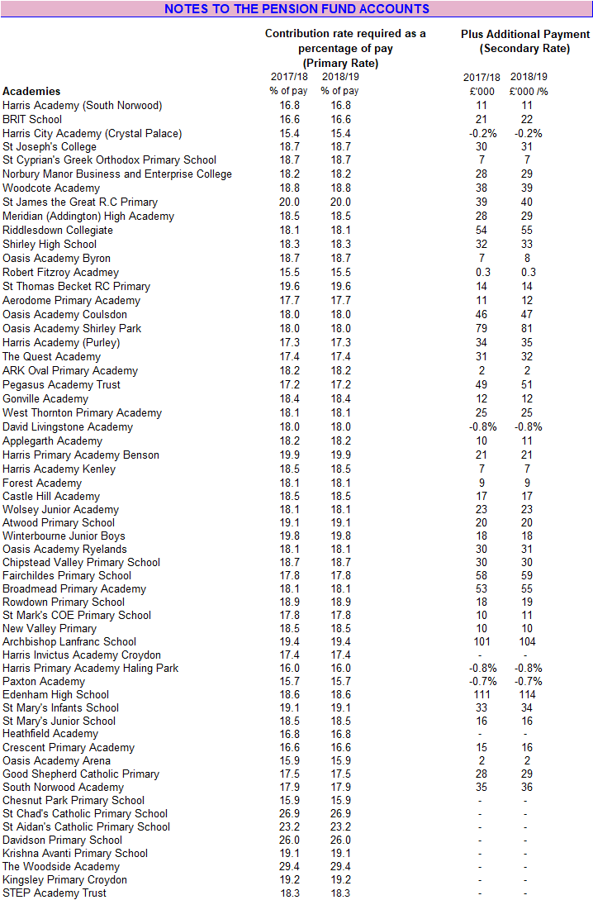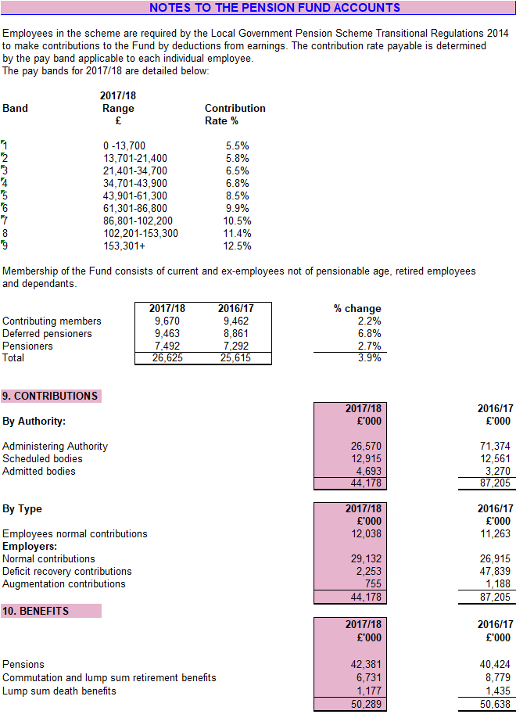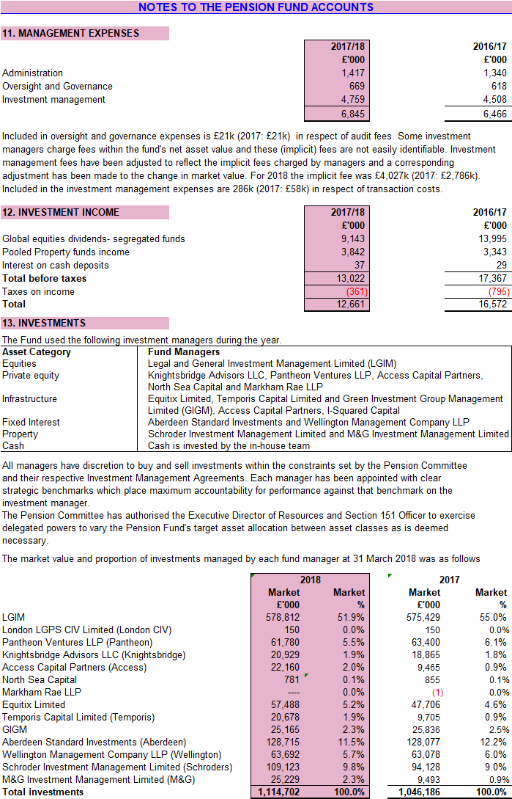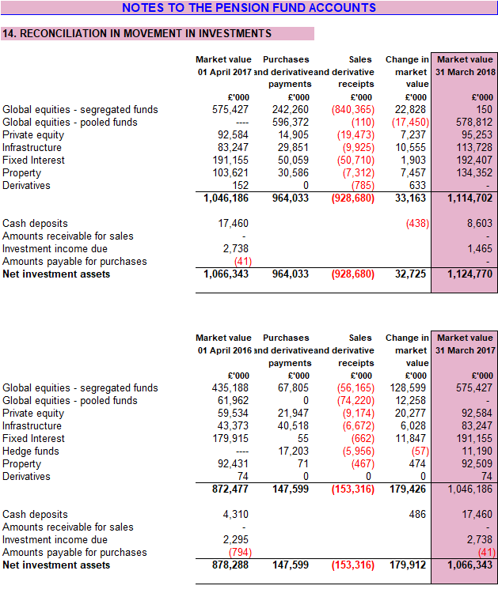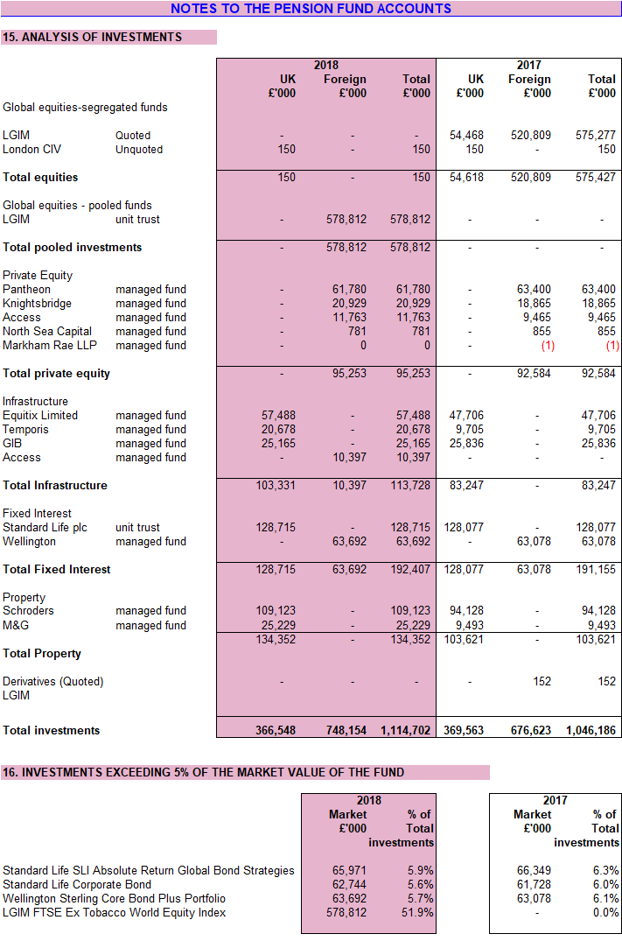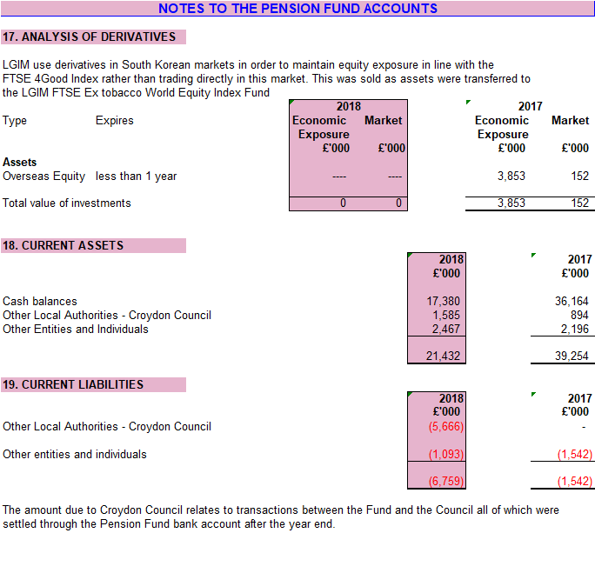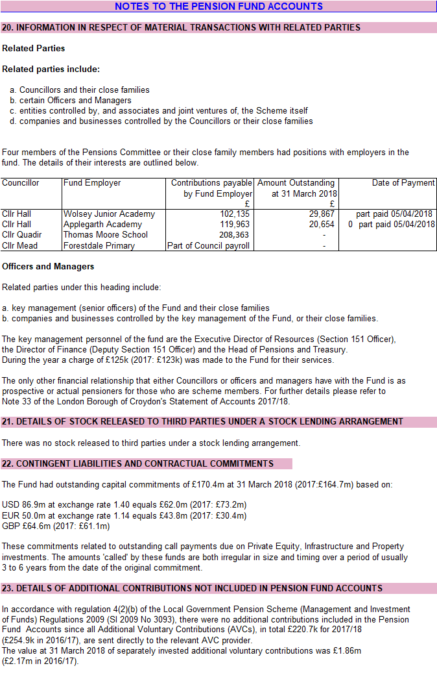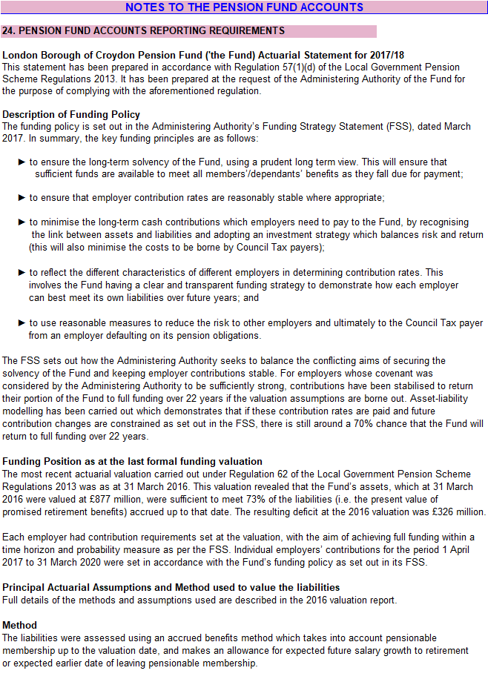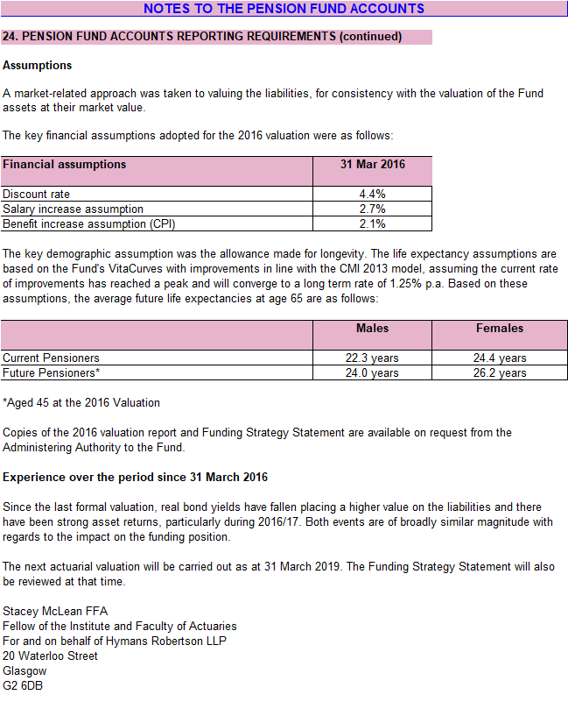
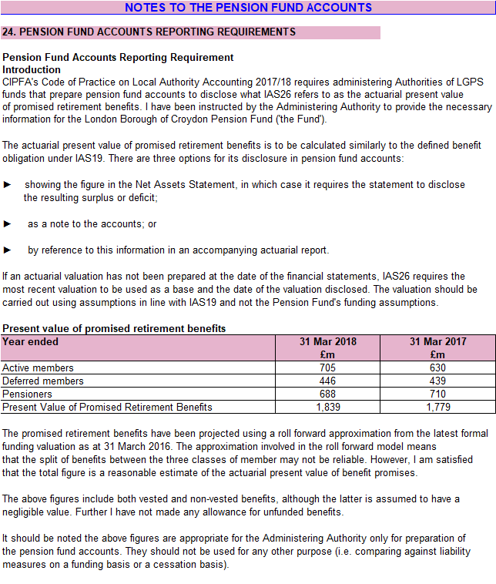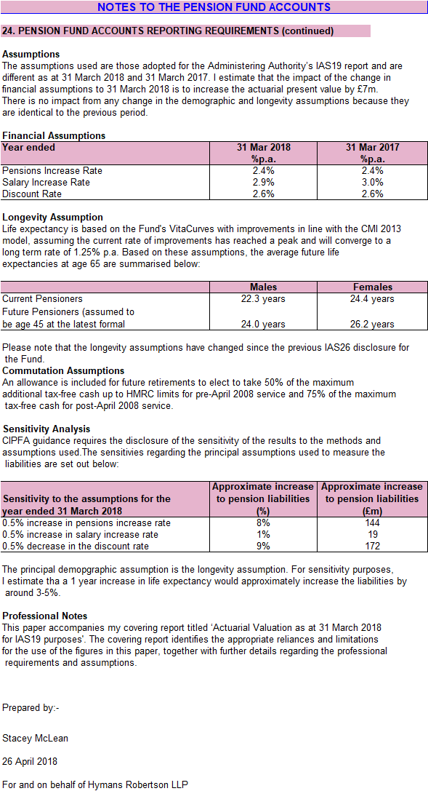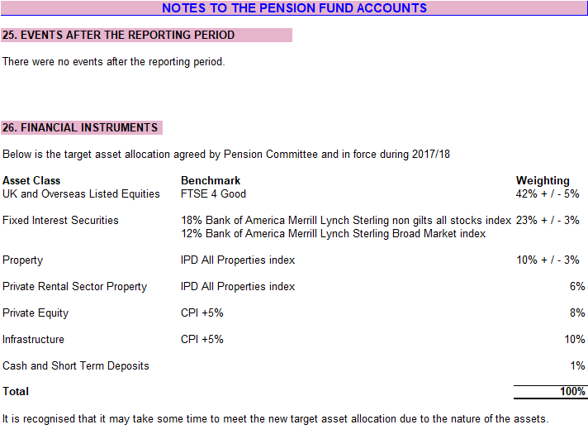
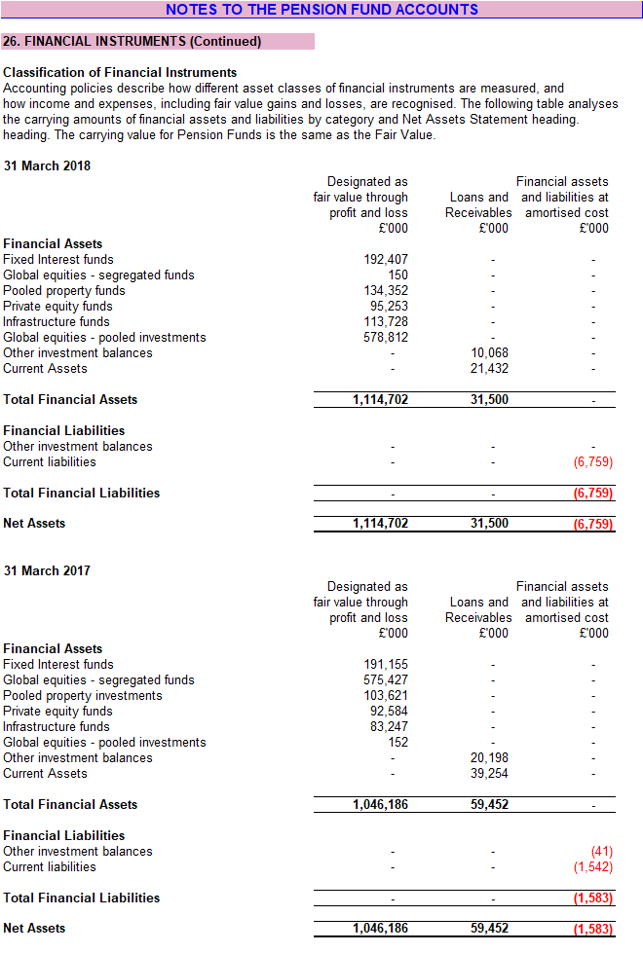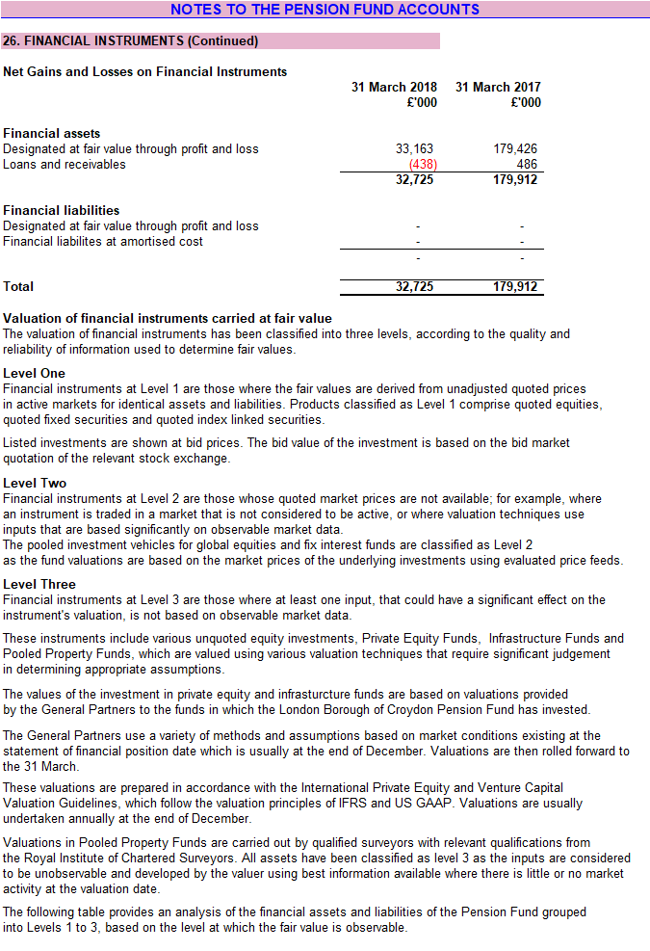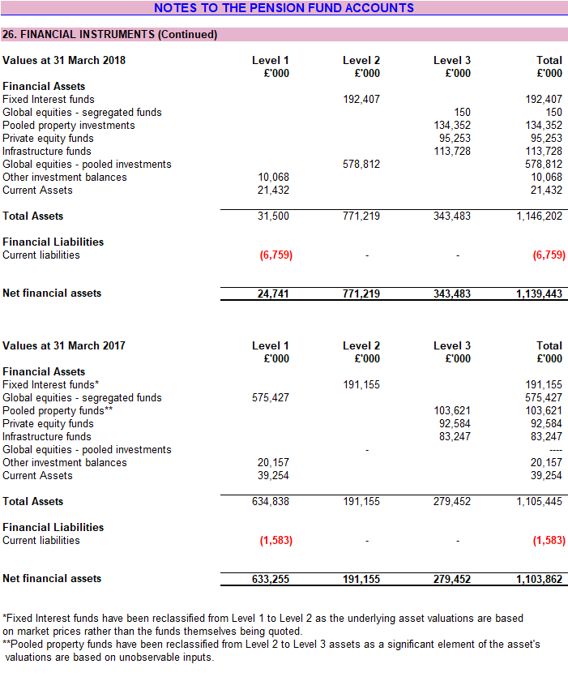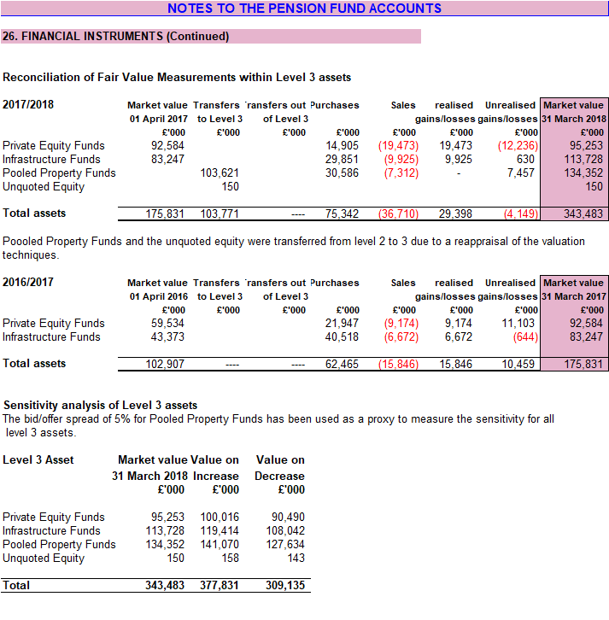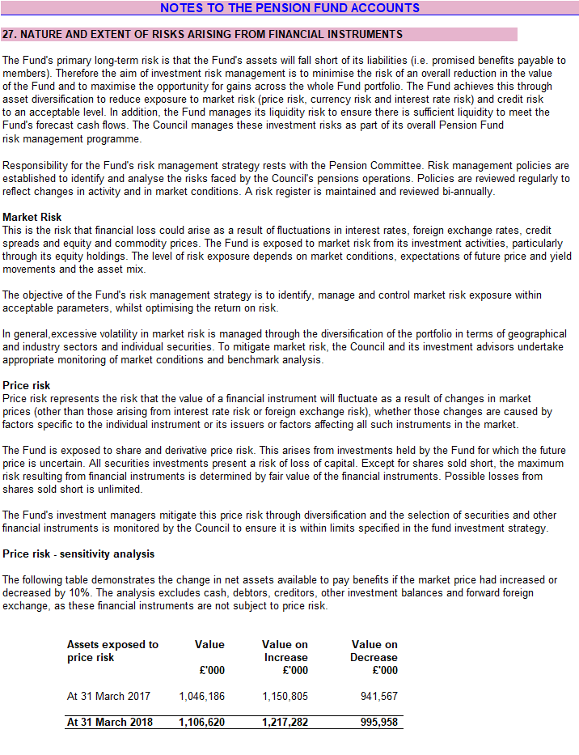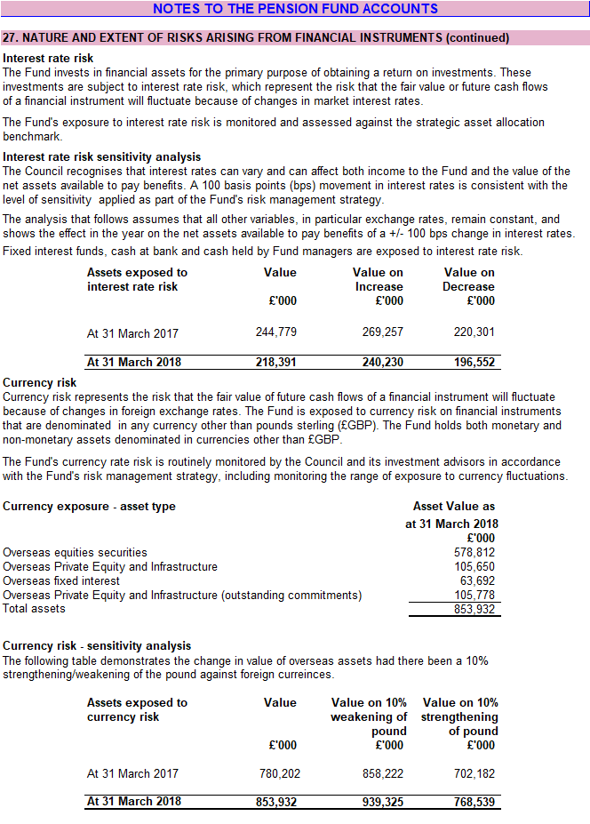
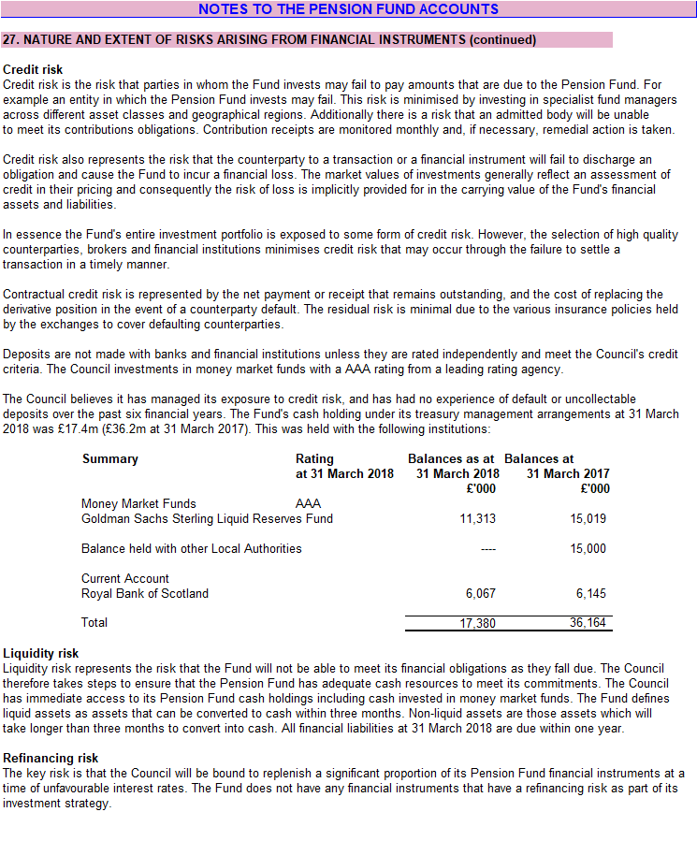

- Pension Fund Auditors Report

